

REVERSE ENGINEERING LAB

This Lab allows you to analyse product functionality, analyse subcomponents, estimate costs, and identify potential patent infringement.

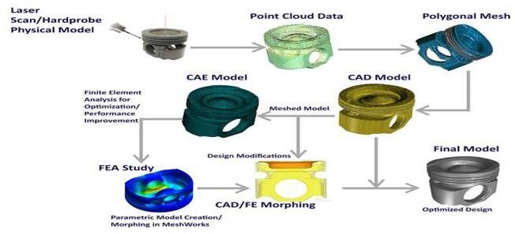

In this lab we can Recreate the vintage models and analyse the failures caused and work on rectifications and developments.

* **Hardware Equipped:**

|  |  |  |  |
| --- | --- | --- | --- |
| **Sr.No** | | **Description** | **Qty** |
| 1 |  | Prime Scanner+ R5 FOV 400 - LED Blue (ART110242) Consisting of: | 1 |
|  | a. | PrimeScan+ R5 Basic Sensor (ART110263) S/N ASN200212 | 1 |
|  | b. | PrimeScan+ R5 FOV 400 (ART110301) S/N ASN190769-L,  Calibration Plate | 1 |
|  | c. | Power Supply Cable (ART109323) | 1 |
|  | d. | Sensor Cable +USB3 connection 5m (ART110072) | 1 |
|  | e. | OptoCat-Remote control (ART101189) 4217-13-1484 | 1 |
|  | f. | Certification for optical 3D measuring systems | 1 |
|  | g. | SMA 12months in Dongle (Blue-Black) Dongle ID:  980115R06 | 1 |
|  | h. | Starter Kit for 3D measuring system (for all FOVs) (ART109208) | 1 |

|  |  |  |  |
| --- | --- | --- | --- |
| 2 |  | Laptop Mobile Precision 5530 Workstation (70RLWT2) CI7/32GB/512GB+2TB/QP1000/WIN-10PRO/16 GB DDR-4 RAM | 1 |
| 3 |  | Tripod Stand, Manfrotto Triaut Camera Tripod BLK (058B) (808RC4) | 1 |

* **COURSES OFFERED:**

|  |  |  |
| --- | --- | --- |
| **S. No** | **Name of the Course** | **Duration** |
| 1 | Reverse Engineering | 40 Hours |

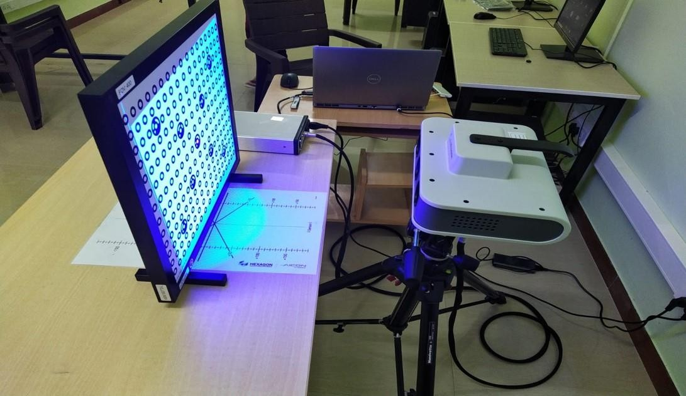

# REVERSE ENGINEERING:

Reverse engineering is a method of creating a 3D virtual model from an existing physical part for use in 3D computer-aided design (CAD), computer-aided manufacturing (CAM), computer-aided engineering (CAE), or other software. The

process involves measuring an object and then reconstructing it as a 3D model.

Reverse engineering is useful to analyse product functionality, analyse subcomponents, estimate costs, and identify potential patent infringement. It may also be used to supply documentation that was either lost or never written, typically for parts designed before [CAD software](https://www.hexagonmi.com/products/software/pc-dmis/pcdmis-vision) became widespread.

* **Soft wares Equipped:**

|  |  |  |
| --- | --- | --- |
| **Sr. No.** | **Name of Software** | **Qty.** |
| 1 | Geomagic Design X | 5 |
| 2 | Geomagic Control X | 1 |
| 3 | Optocat 2020R3 | 1 |

# Table of Contents

**Introduction to Reverse engineering 6**

**Understanding Reverse engineering technics 11**

**Reverse engineering Parameters 13**

**Advantages of Reverse Engineering 15**

**Applications of Reverse Engineering 16**

**Introduction to Calibration 20**

**Calibration positions 24**

**Calibration Process 28**

**Introduction of Scanning Methods and Types 32**

**Contour Matching Method 36**

**Contour Matching Method Process 36**

**Data Processing 47**

**Target Matching Method 60**

**Target Matching Method Process 60**

**Data Processing 73**

**Introduction to Geomagic Design X and Interface 86**

**Workflow Process in Geomagic Design X 88**

**Work Process 89**

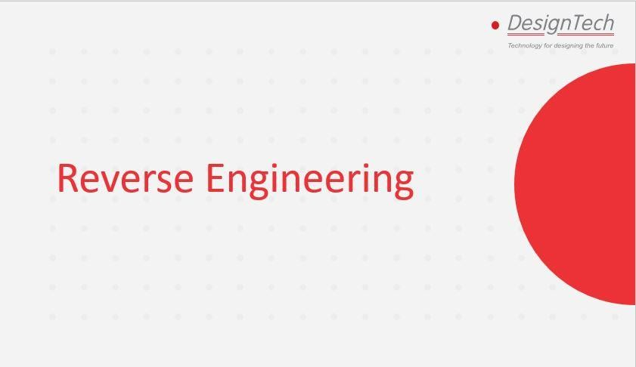

Description:

Introduction about Reverse Engineering.

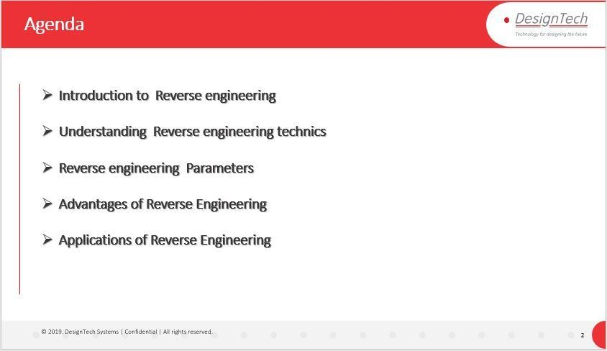

Description:

Explain the Agenda and topics of Reverse Engineering.

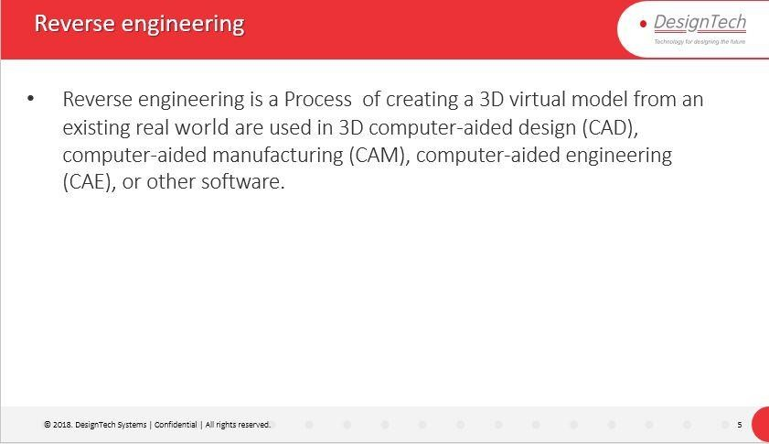

Description:

* Reverse engineering is a Process of creating a 3D virtual model from an existing real world are used in 3D computer-aided design (CAD), computer-aided manufacturing (CAM), computer-aided engineering (CAE), or other software.

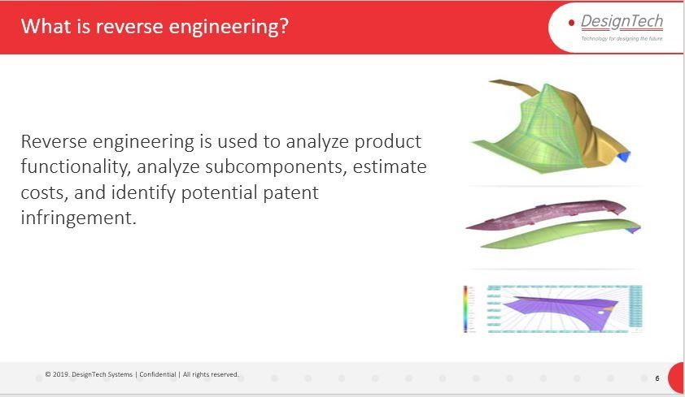

Description:

Reverse engineering is used to analyze product functionality, analyze subcomponents, estimate costs, and identify potential patent infringement.

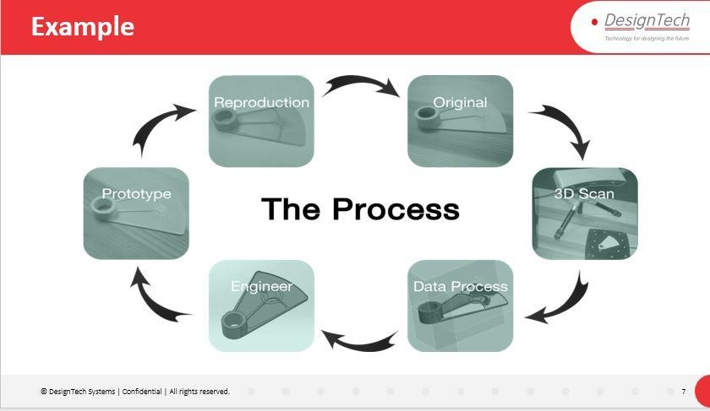

Description:

Example for reverse engineering.

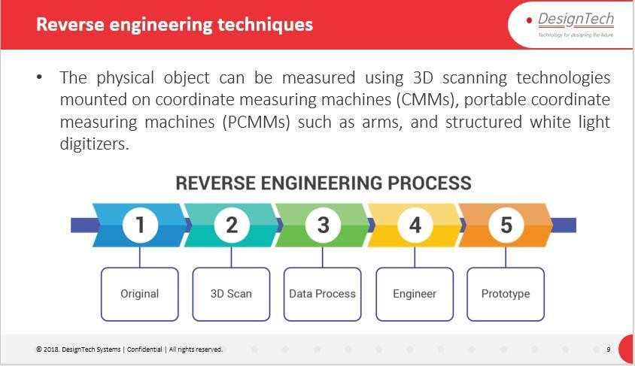

Description:

The physical object can be measured using 3D scanning technologies mounted on coordinate measuring machines (CMMs), portable coordinate measuring machines (PCMMs) such as arms, and structured white light digitizers.

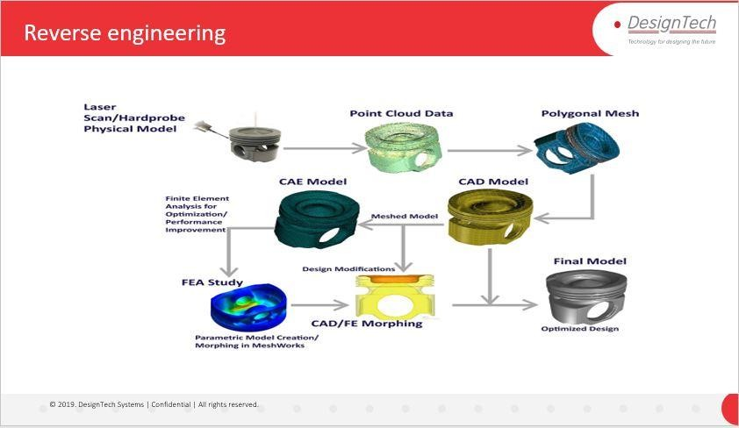

Description:

One more Example for Reverse Engineering.

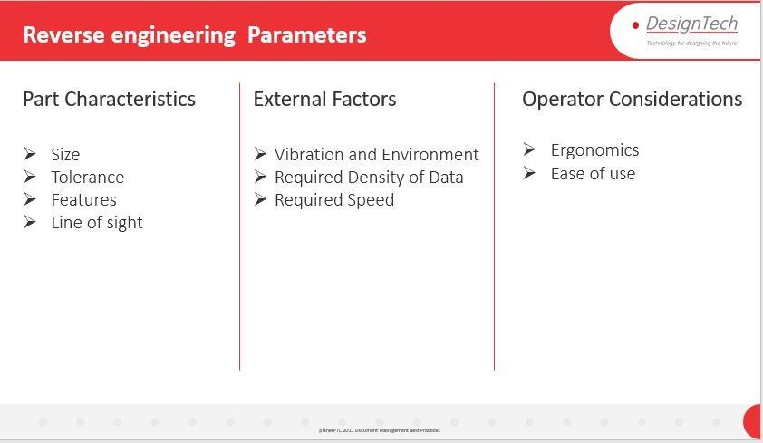

Description:

Part Characteristics

**Size**:

Small parts often have tight tolerances which typically exclude them from scanning technology. This is because noise level (and uncertainty) of this method usually exceeds the tolerance of the part. Probing or analog scanning with a CMM, and the appropriate probe tip size, is usually ideal in these circumstances.

**Tolerance**:

Prismatic machined features, such as planes and holes, or parts that require high accuracy (less than 25- microns per meter) should be contact probed on CMMs or PCMMs. The downside to scanning with probes is a longer data collection time and an increased risk of the part accidentally moving during measurement.

Flexible parts and parts with complex contoured shapes should be measured with non-contact scanners when possible.

**Features**:

Relief patterns, cast holes, and edges are some of the features that need to be taken into account. Analog probing can measure small radii very accurately, but the process is slow. Laser scanners set to minimum point spacing can pick up fine details, but small features can get lost in the uncertainty noise.

**Line of sight**:

Probes can reach areas out of the line-of-sight of scanners. Laser scanners may have difficulty getting into tight areas due to head size and short stand-off. Most scanners can get data when the sensor is angled about 65-degrees from the surface normal.

External Factors

**Vibration and Environment**:

During the measurement process CMM and PCMM arms, scanners and trackers require that the part be immobile relative to the measurement hardware. This means the inspection environment must be stable.

**Required Density of Data**:

Data density is related to the point spacing (resolution) and thus the fidelity of the measurement. This is often discussed in terms of surface tolerance, or the angular deviation between adjacent points. High density data is often required on features (holes, edge details, etc…) for extraction from point clouds.

**Required Speed**:

A good rule of thumb when weighing the benefits of probe scanning versus laser or white light scanning is to consider both data collection and mesh processing speeds. Typically, a probe will be slower to collect data but will allow it to be processed more quickly. Conversely, laser or white light scanners will allow rapid data collection, but will reduce the mesh processing speed.

**Operator Considerations Ergonomics**

Measuring a large part with a laser scanner can be exhausting due to the need to maintain ±1 inch stand-off to get a 3-inch swath per scan.

**Ease of use**

Measuring points with a manual probe can get tedious if numerous points are required. Manually driven laser scanners generate non-uniform point clouds which can increase the time for mesh processing and production of the final model.

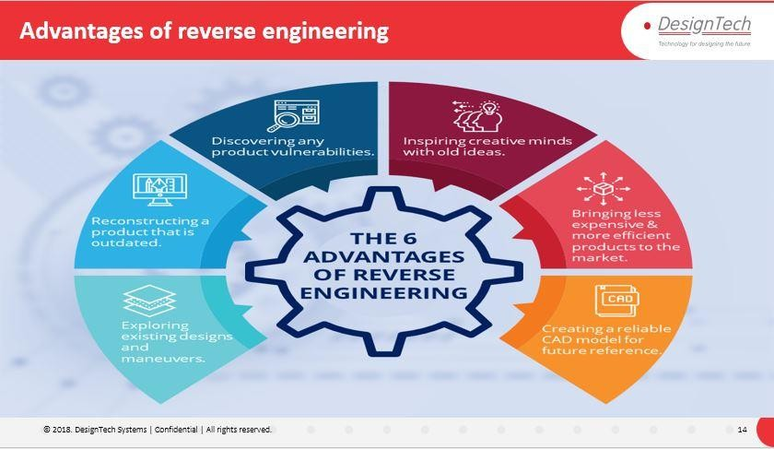

Description:

Advantages of Reverse Engineering.



Description:

Application of Reverse Engineering



Description:

Application of Reverse Engineering in Automotive Industry.

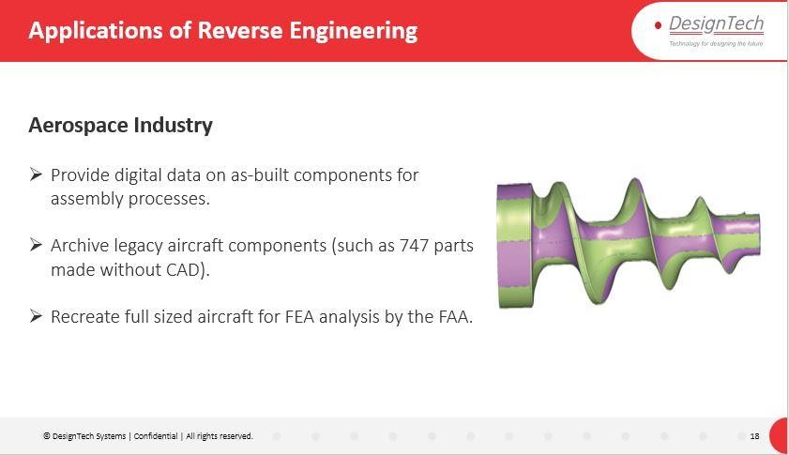

Description:

Applications of Reverse Engineering in Aerospace Industry.

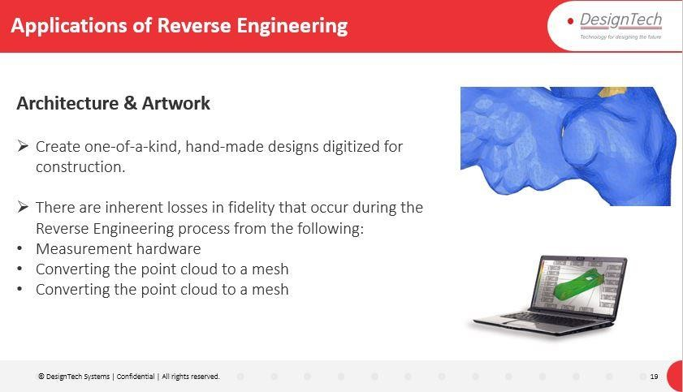

Description:

Application of Reverse Engineering in Architecture & Artwork.

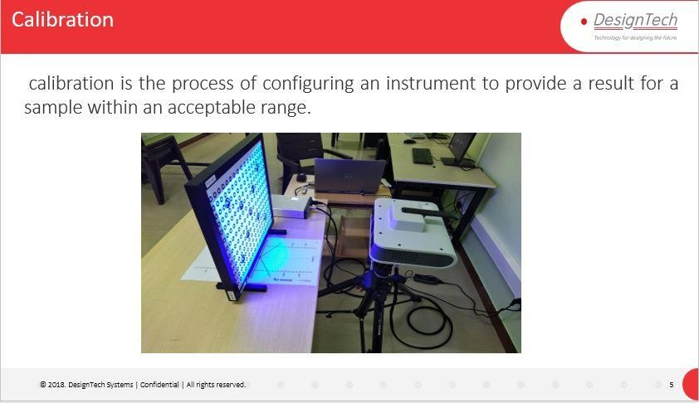

Description:

Explain about Calibration of Reverse Engineering Technique.

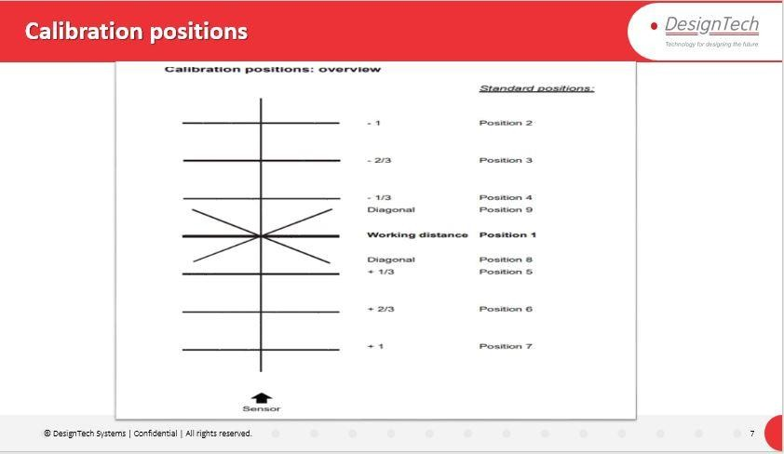

Description:

Calibration Positions.

For prime scanner Reverse Engineering Equipment, we need to perform 9-position calibration Process.

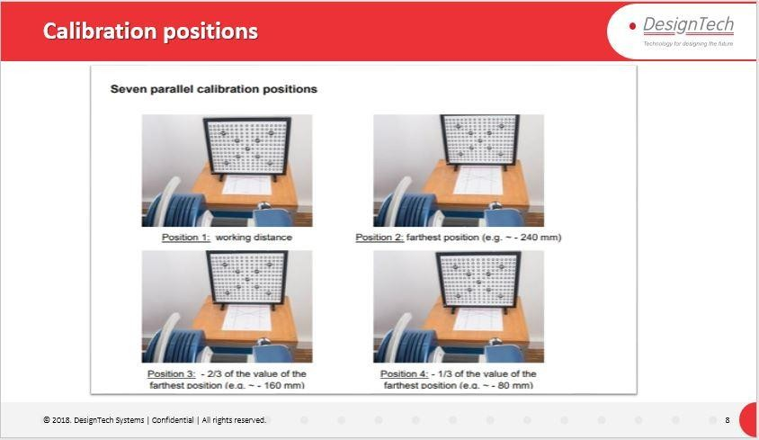

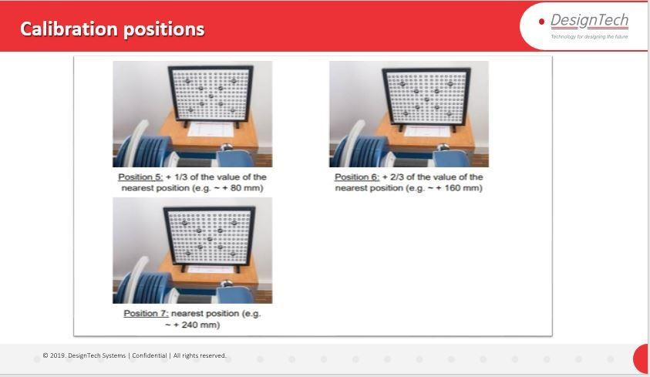

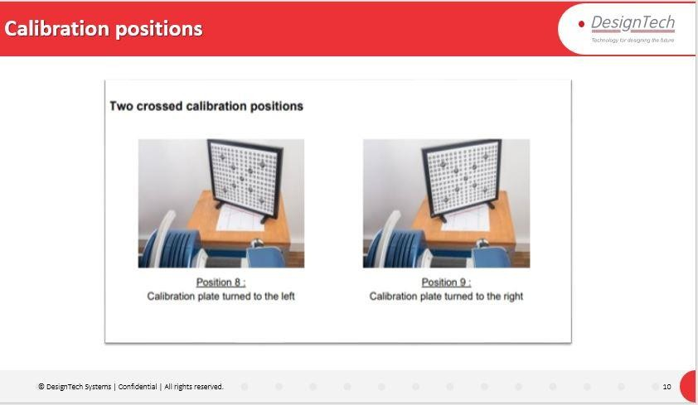

Description:

9 positions of calibration plate for prime scanner.

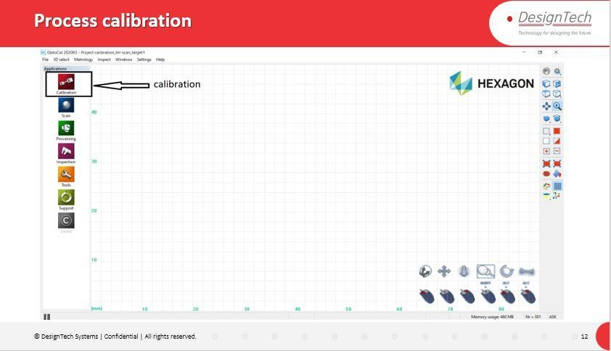

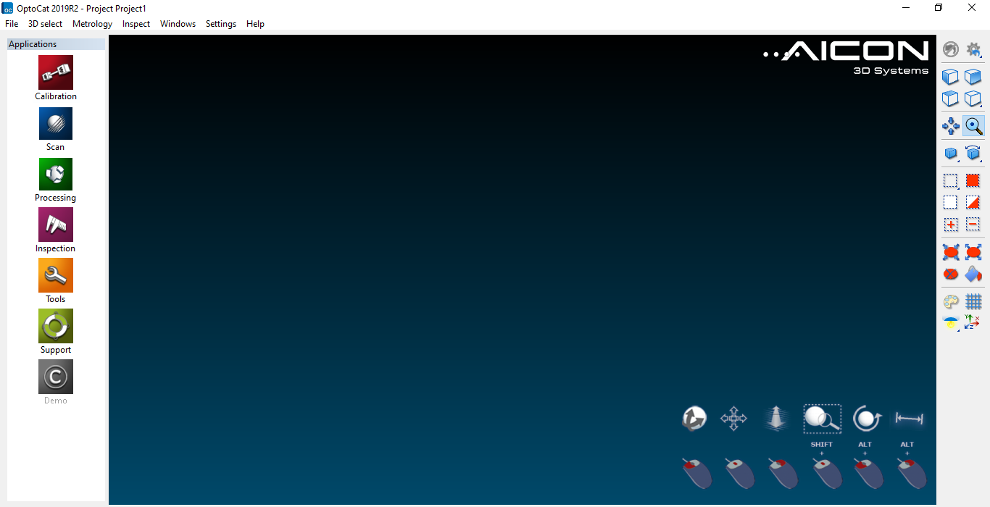

D

Description:

In Optocat Click on **Calibration** option to perform Calibration process from prime scanner.

**Calibration** option will redirect to Calibration window.

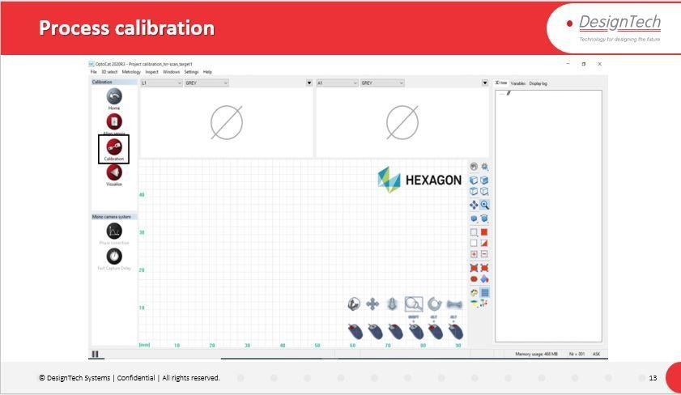

# C:\Users\Administrator\Desktop\pg25.PNG

# Description:

Click On **Calibration** in Calibration window to start Calibration Process.

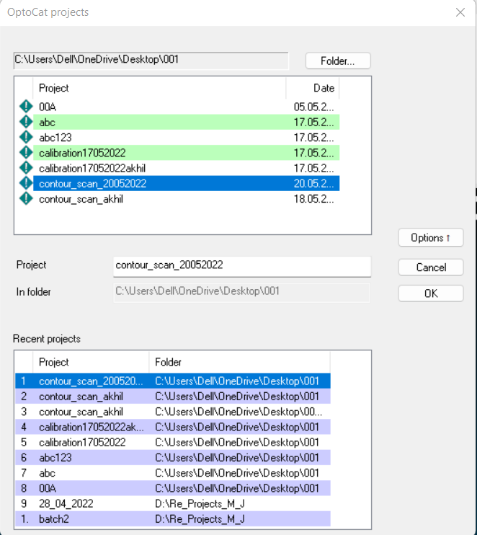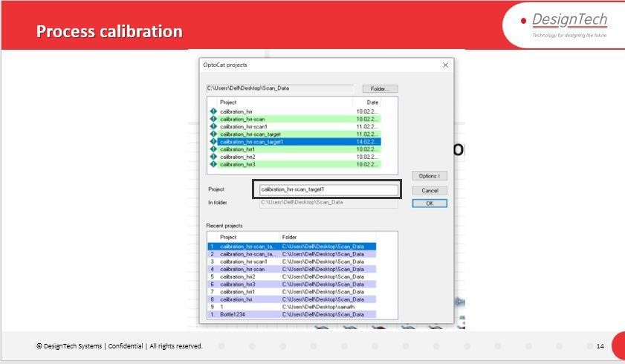

# Description:

Name the Calibration process and Specify the Saving Location Path and Click OK

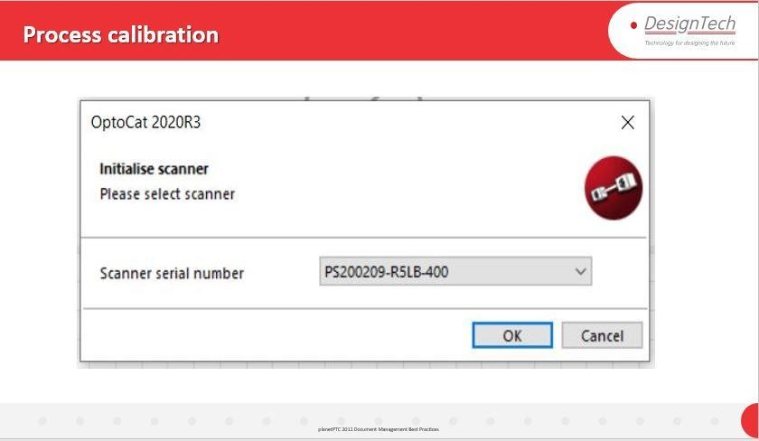

Description:

After Specifying Saving Location Optocat Software Will Detect the Scanner with Serial Number Make sure with the Serial Number and Click OK.

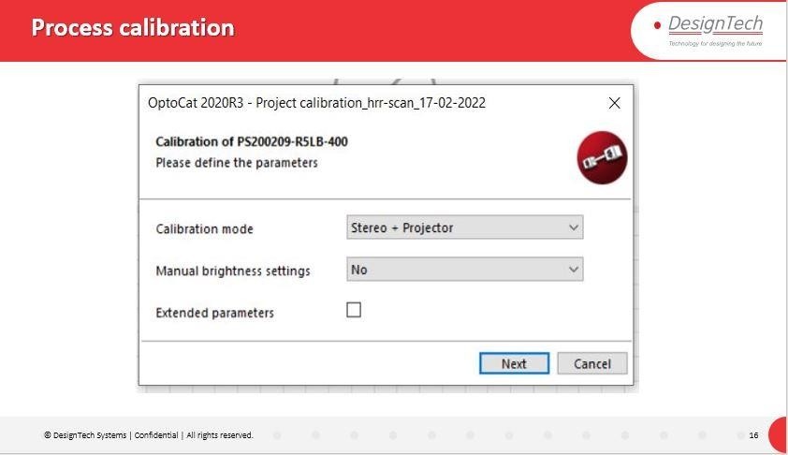

Description:

Select Calibration mode and Click NEXT.

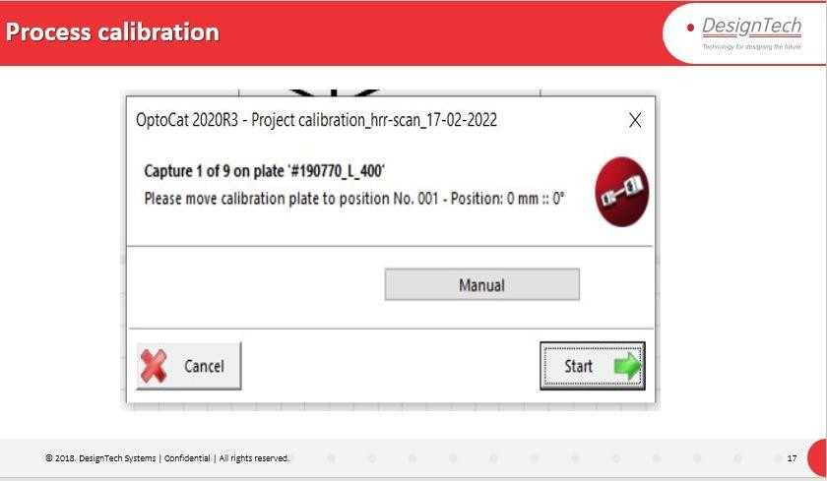

Description:

Place Calibration plate on the sheet in the position 1 and start the calibration Process.

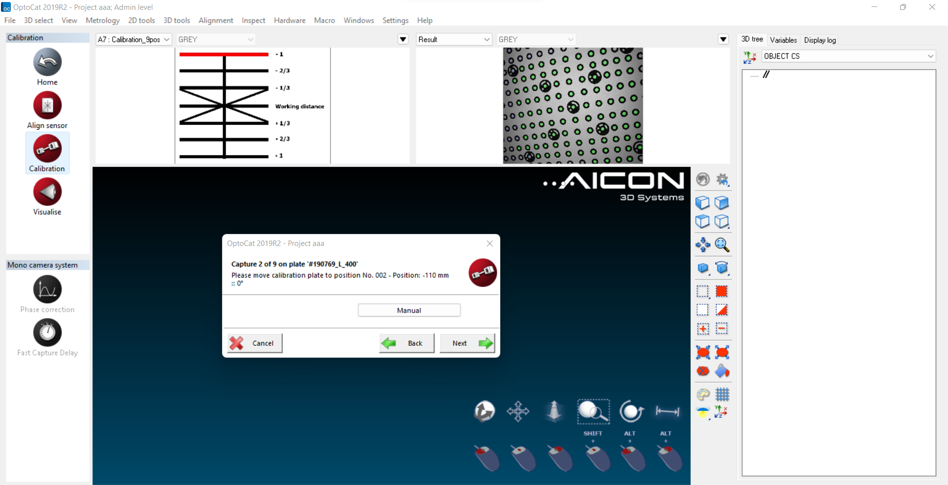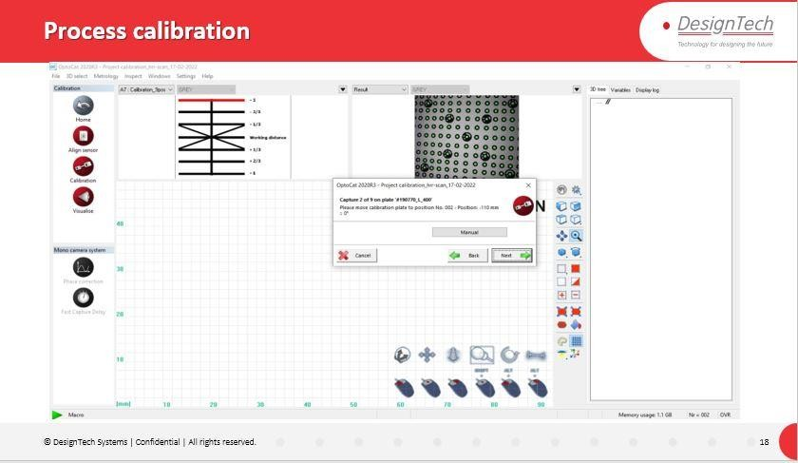

Description:

Repeat the Procedure for 9 Positions as per the Calibration Sheet Chart.

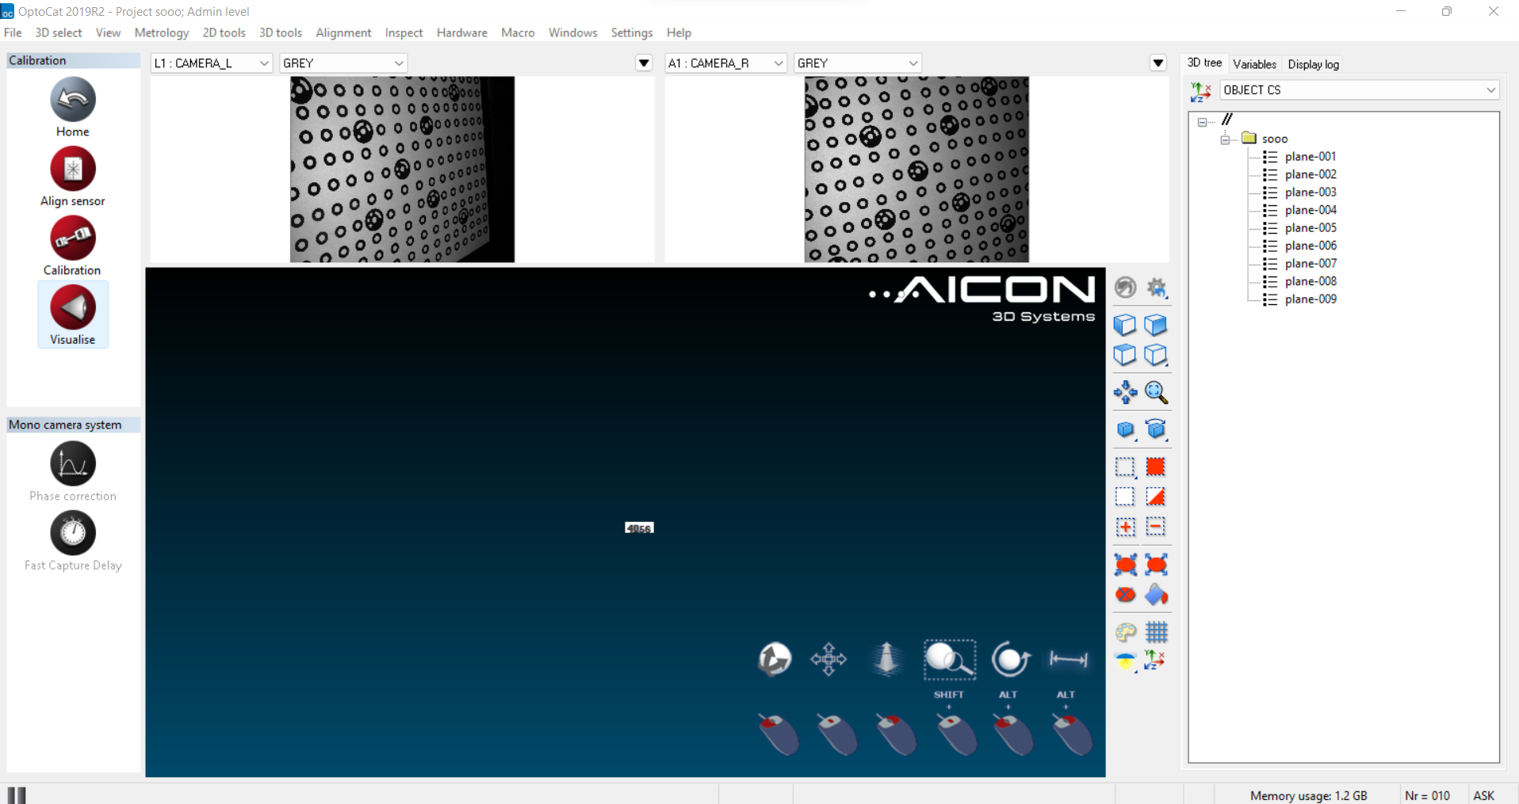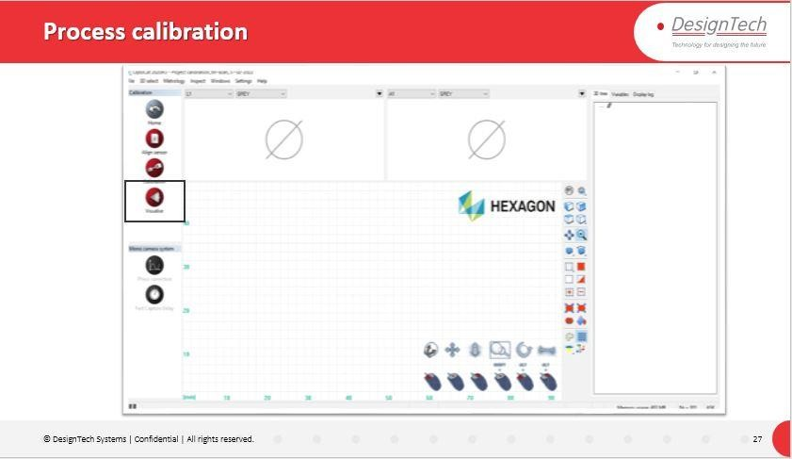

Description:

After Finishing All the 9 Positions Software will analyze all the 9 Position Captures.

Click on Visualize Option to check the How the Capture is Done.

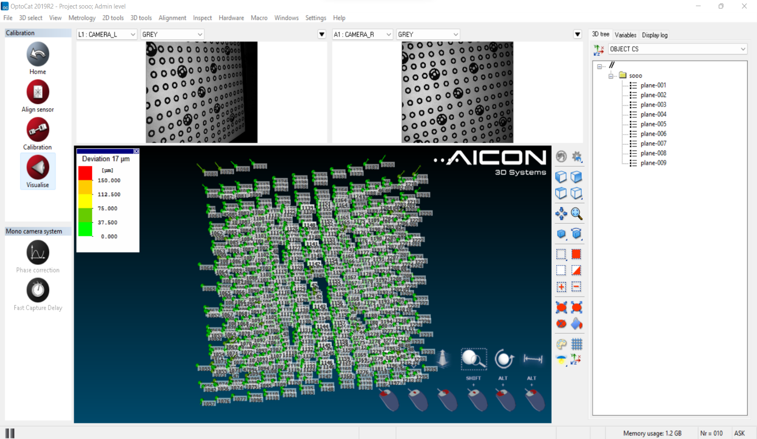

Description:

By Clicking On Visualize Software Will Visualize the Capture Done.

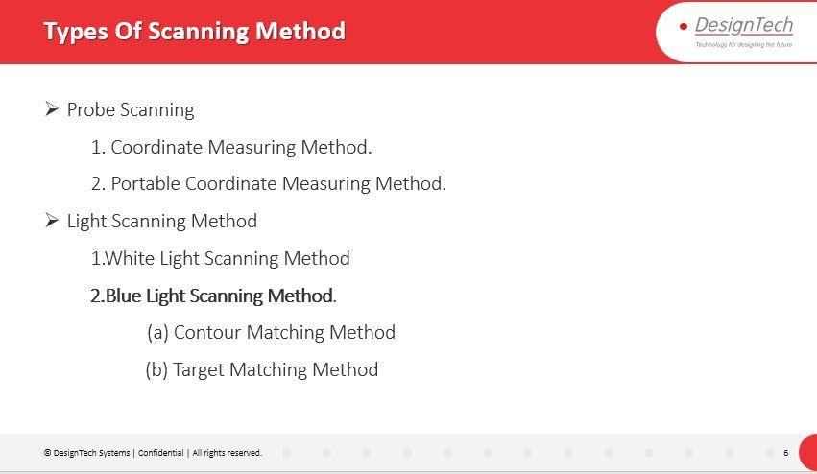

Description:

Types of Scanning Methods we will Proceed with Blue Light Scanning Method.

1. **Contour Matching Method**: For Non-Symmetrical components we will proceed with Contour Matching Method.
2. **Target Matching Method**: For Symmetrical Components we will proceed with Target Matching Methods by Pasting Target points on the component to Capture the Model.

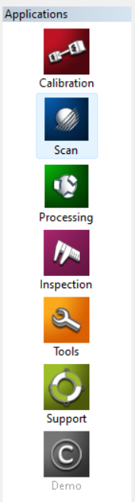 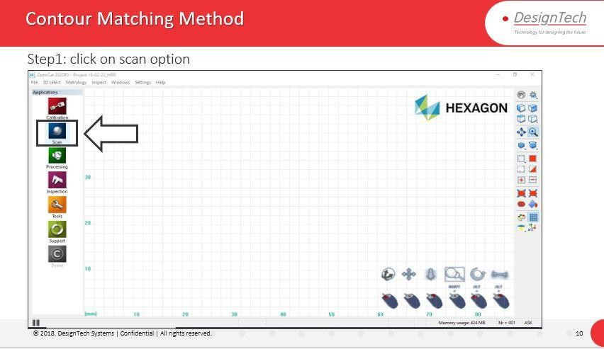

Description:

Click On Scan Option.

Scan Option Will Take us to Window to Capture the Model.

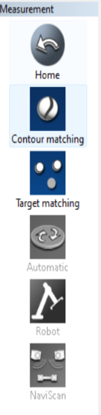 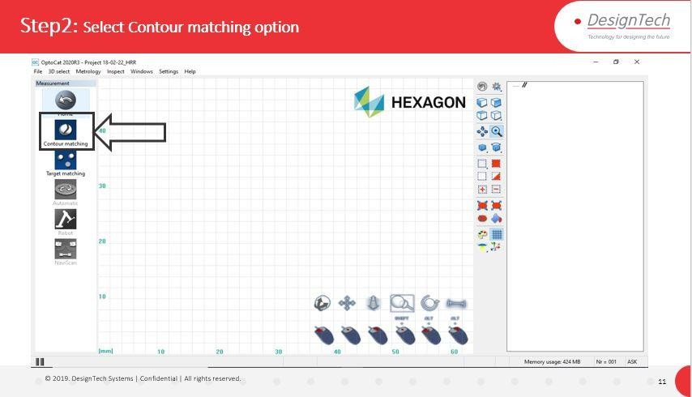

Description:

In Scan Window We Can Select the type of Scanning Method.

Select **Contour Matching**.

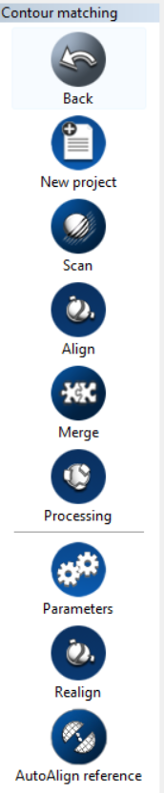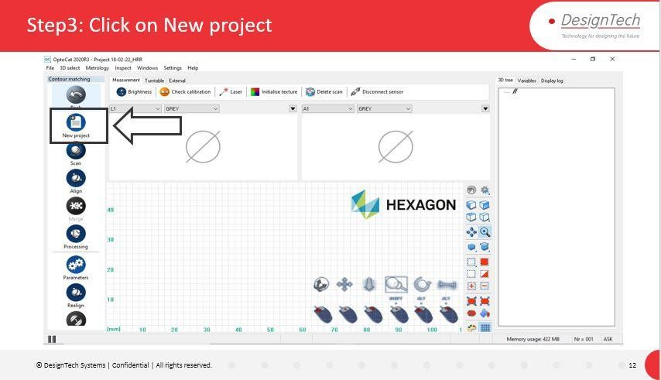

Description:

Select **New Project** to Create New Project to continue Scanning Process.

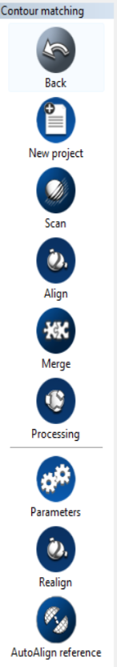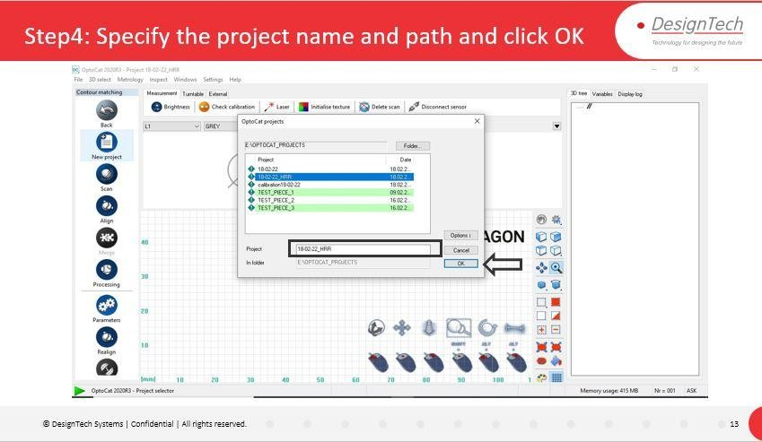

Description:

Name the Project and Specify the location and Click OK.

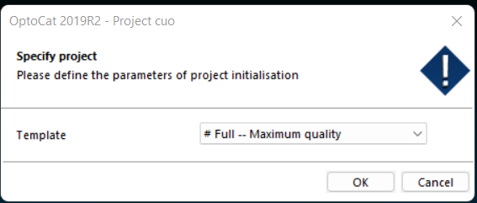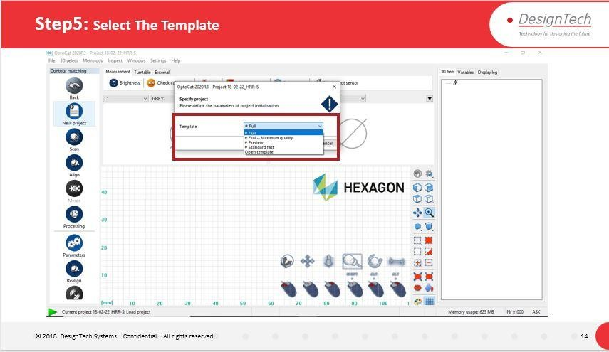

Description:

Select Template which uses to Capture Data from Model/Component.

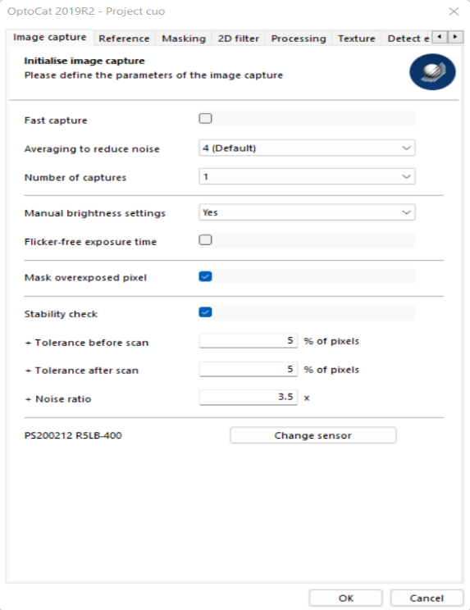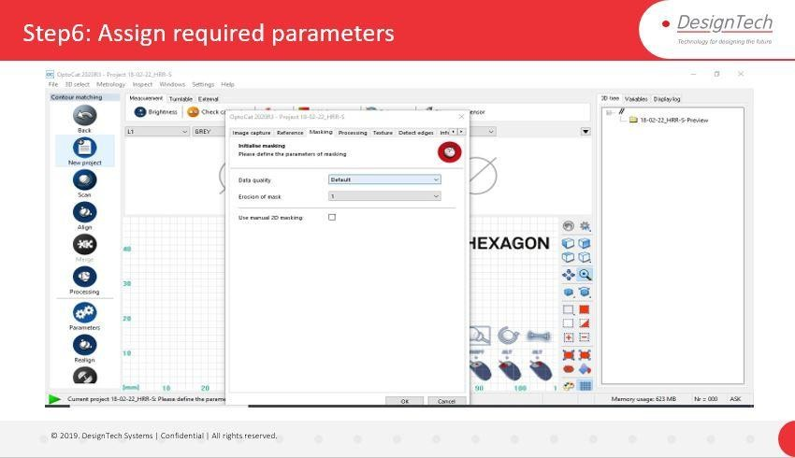

Description:

Specify the Parameters from Parameter window.

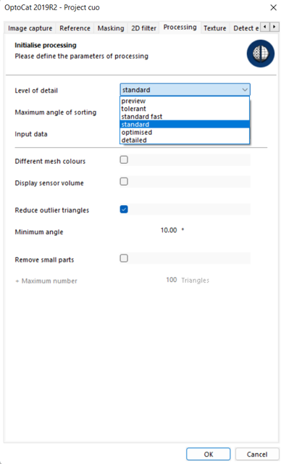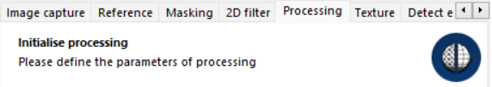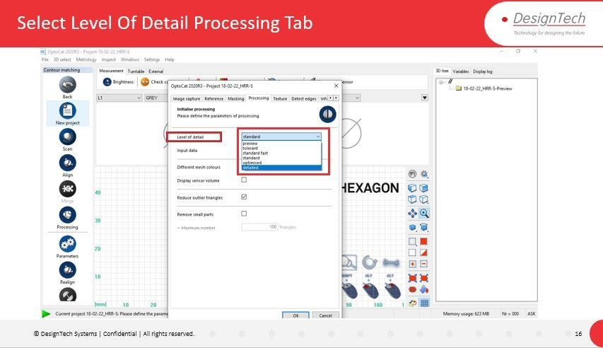

Description:

In the **Processing** Tab Select **Level of Detail** to get the Data Accurately.

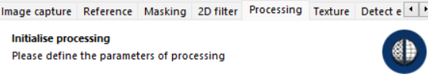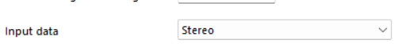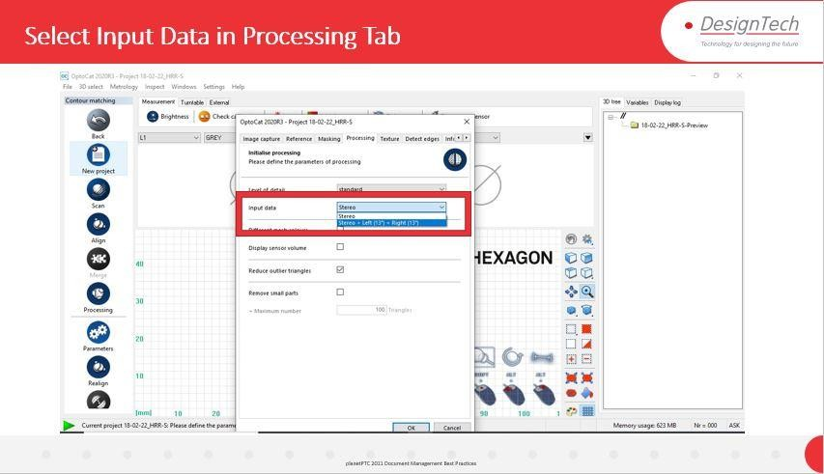

Description:

After Selection of Level of Detail Select **Input Data** from Processing Tab Again.

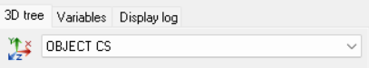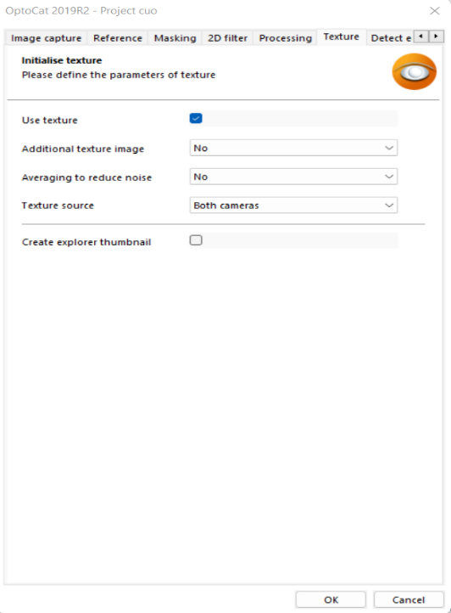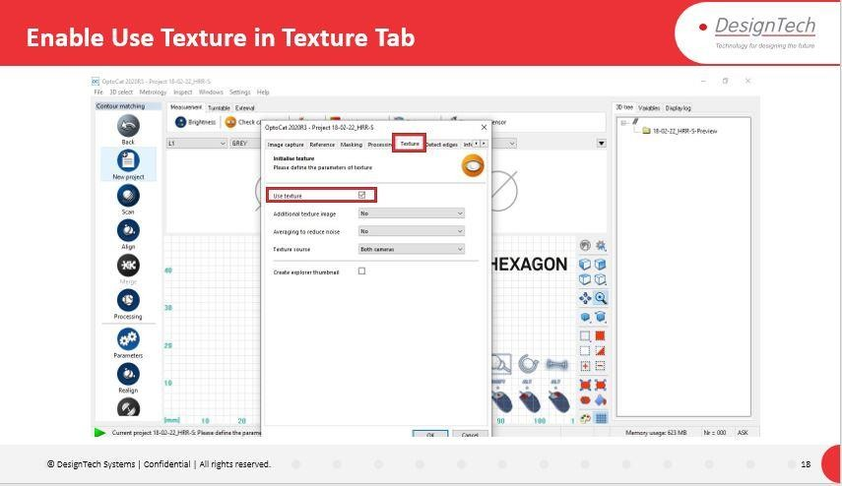

Description:

Click On **Texture** Tab and in Texture Tab Enable **Use Texture** Option If we want to scan the model along with Texture of Component.

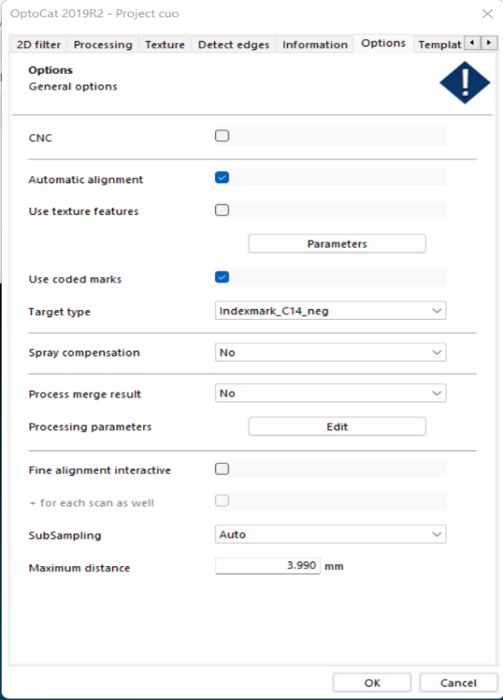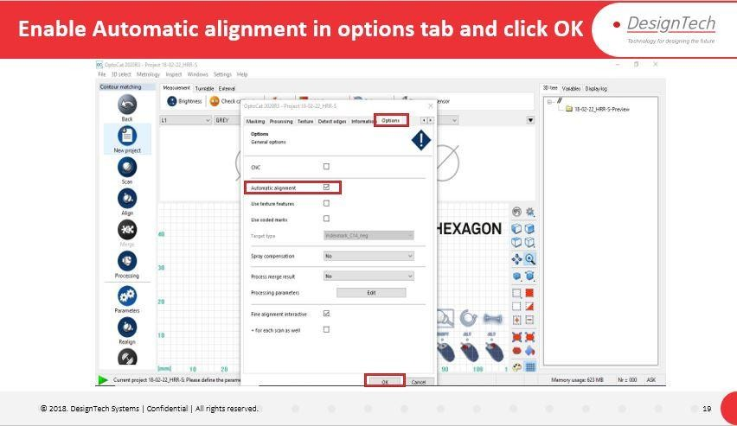

Description:

Now Click on **Options** Tab and Enable **Automatic Alignment** which align the

captured data of component automatically. If we didn’t Enabled, then we have to align the Captured Data Manually by Picking up the Similar Point Location on the captured model.

Click **OK.**

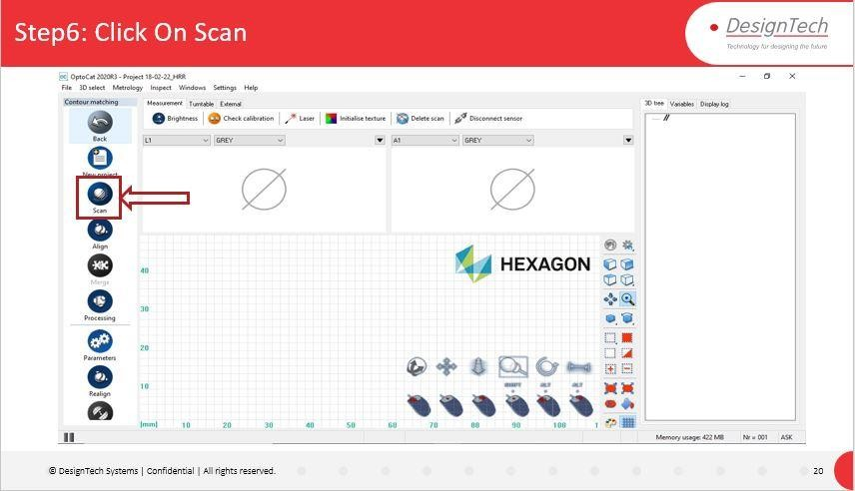

Description:

Click on **Scan** Option to start the Scanning Process.

**Sensor** Dialogue box will Appear.

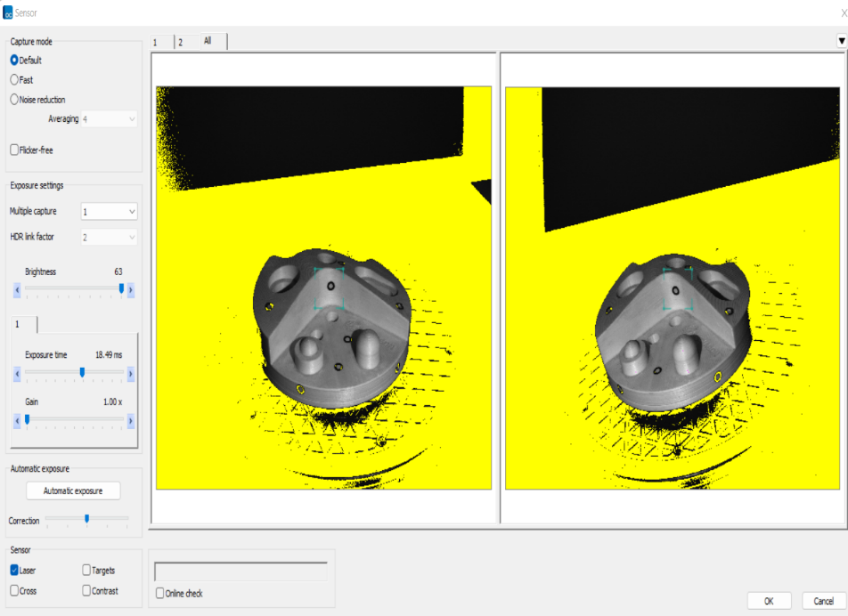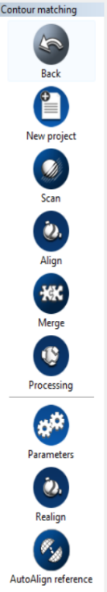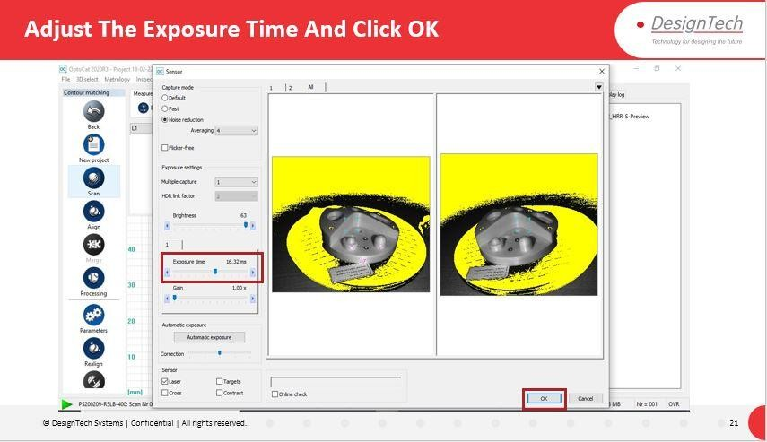

Description:

In **Sensor** Dialogues Box can adjust the **Exposure Time** Bar to Increase or decrease the Light Reflection and Data Capture Accuracy on the model component.

We can change Noise Reduction and Brightness.

We can Use **Automatic Exposure** to Adjust the Light Reflection automatically.

Enable **Laser** Option Under **Sensor** Section.

Click **OK.**

Scanning Will start and It Will Capture the Component Data.

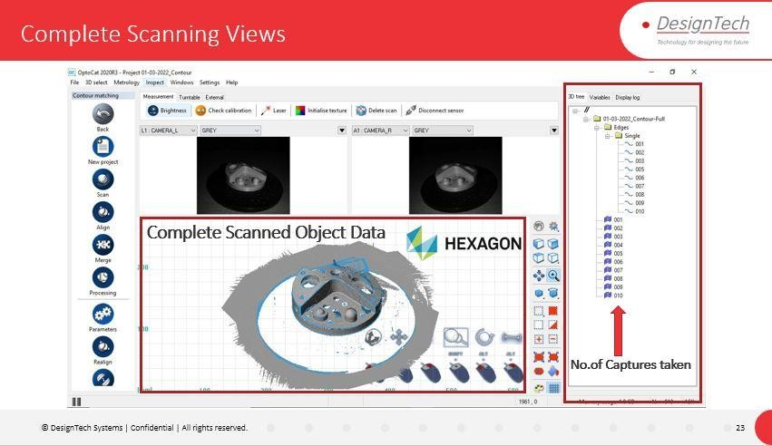Repeat the Same Procedure Until we capture the Complete Model data From all Directions of the component.

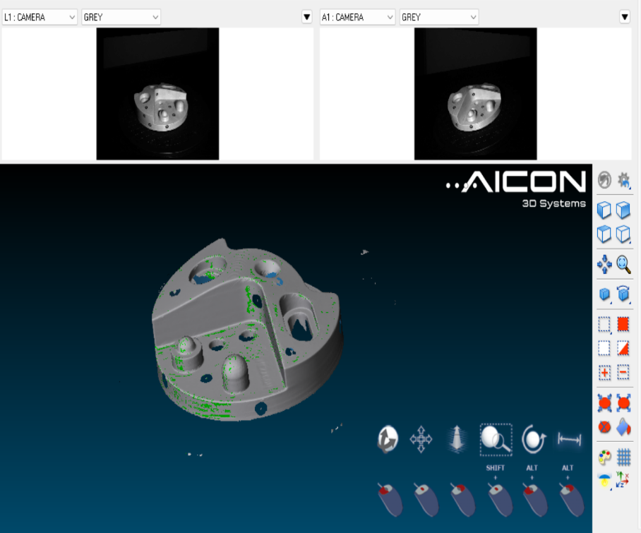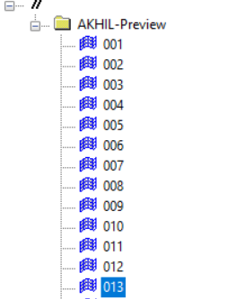

Description:

After completion of Scanning Process, we can find the Captures from 3D tree Tab.

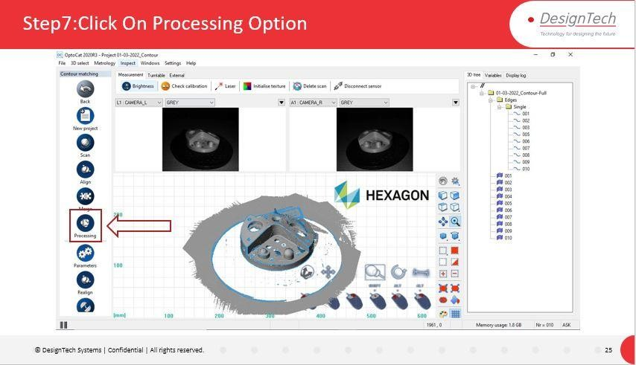

Description:

After the Scanning Process Click on **Processing** Option to proceed for Data Processing.

It will redirect to Processing Window.

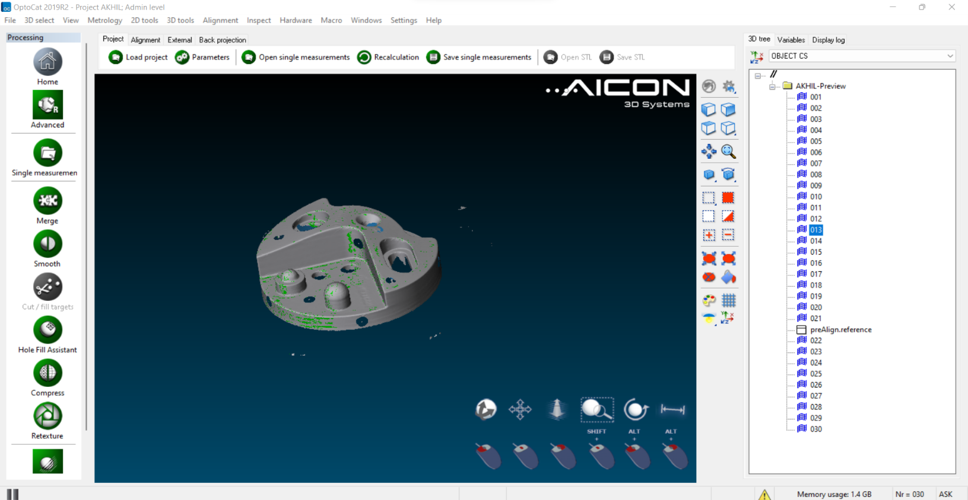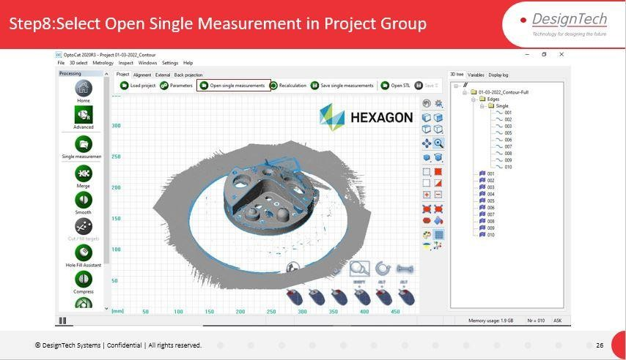

Description:

In Processing Window Click on **Open Single Measurements** option to Open the Multiple Scanned Captures.

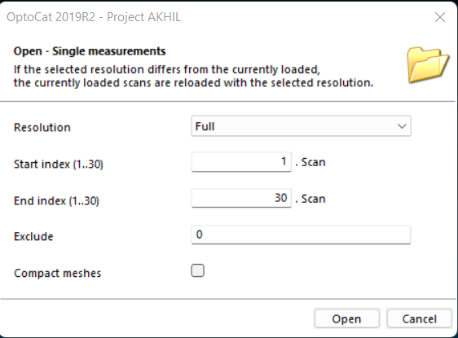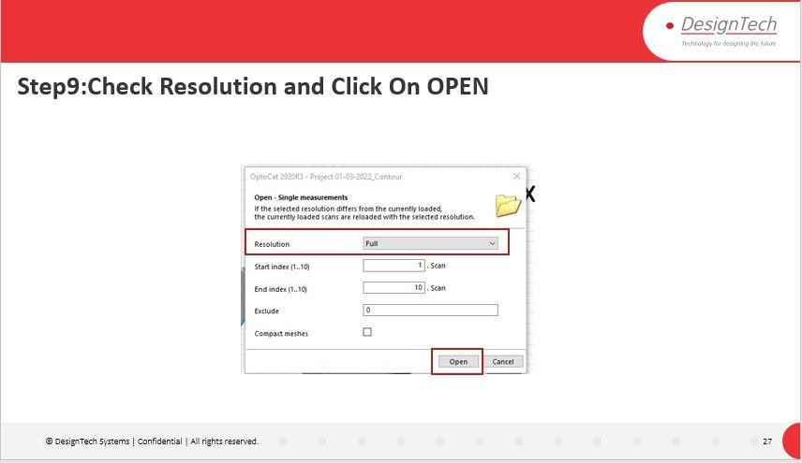

Description:

In Open Single Measurements Dialogue Box Select **Resolution** as **Full** and Click on

# Open.

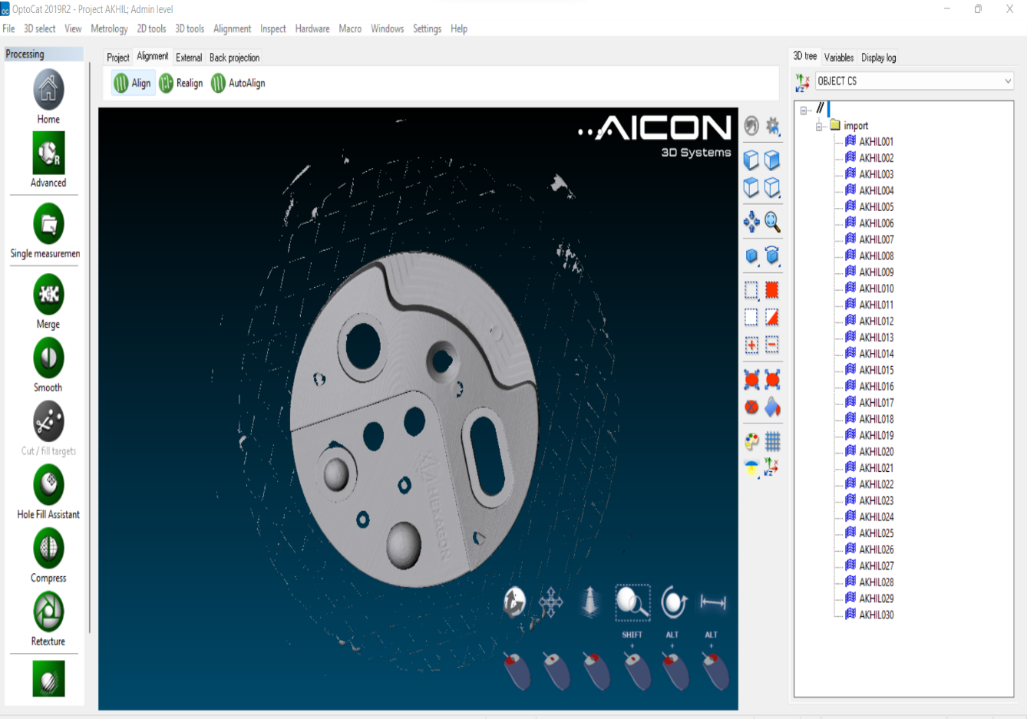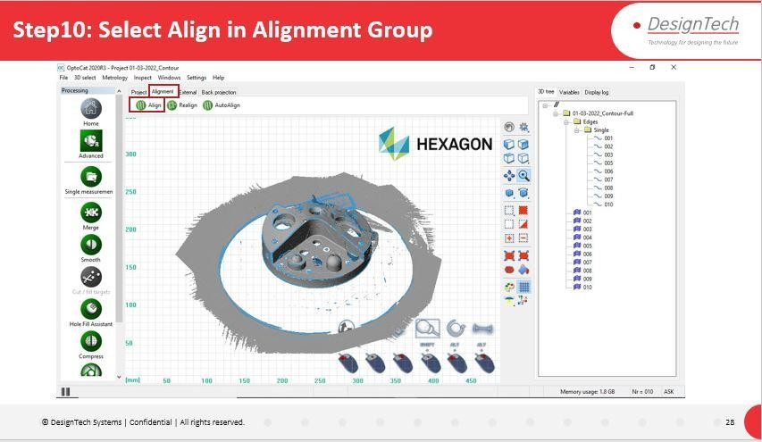

Description:

After Open the single Measurements Click On **Align** Option in **Alignment** Tab. To align the Multiple Captures in to Proper Shape and Position.

Align Dialogue Box Will pop up.

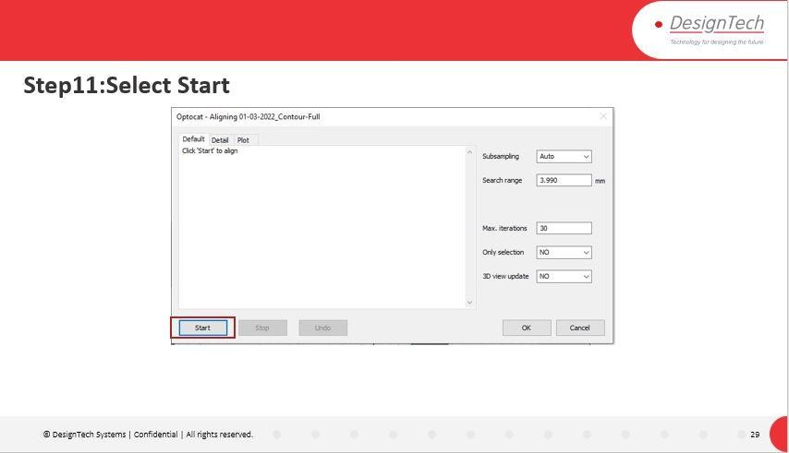

Description:

Click on **Start** Option in Align Dialogue box which will starts the alignment of capture of model.

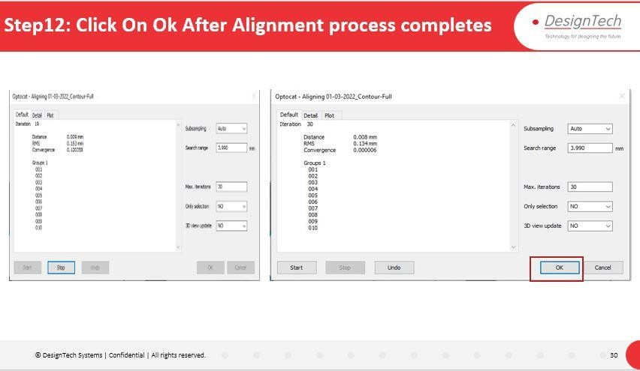

Description:

Alignment Process will start with 30 iterations which we can find in the dialogue box.

After finishing of Alignment Process with 30 iterations Click on **OK.**

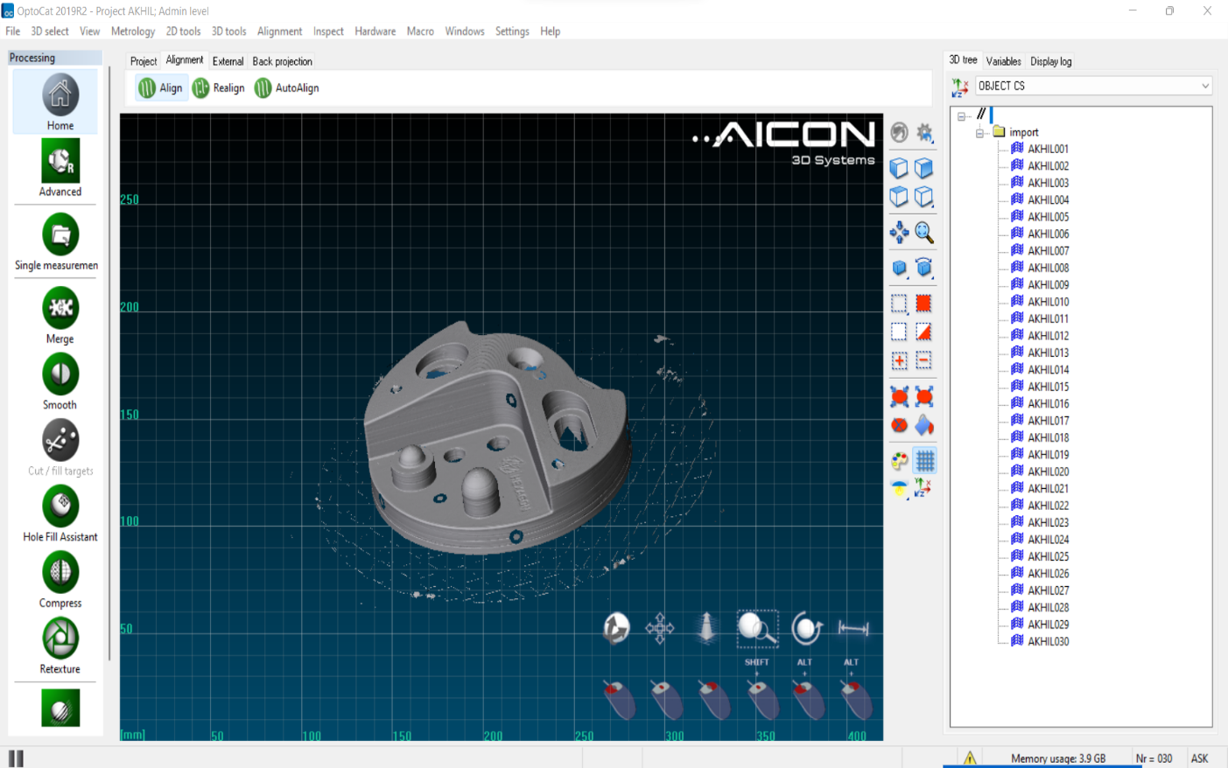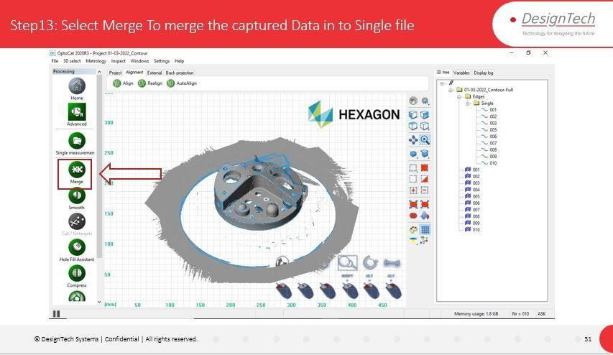

Description:

Click on **Merge** Option after completion of Alignment Process.

Merge option will merge the multiple captured data in to Single Capture Data.

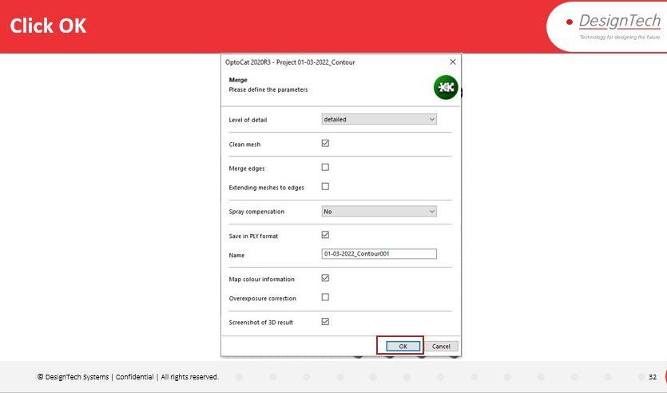

Description:

In Merge Dialogue Box Check the details and Click **OK.**

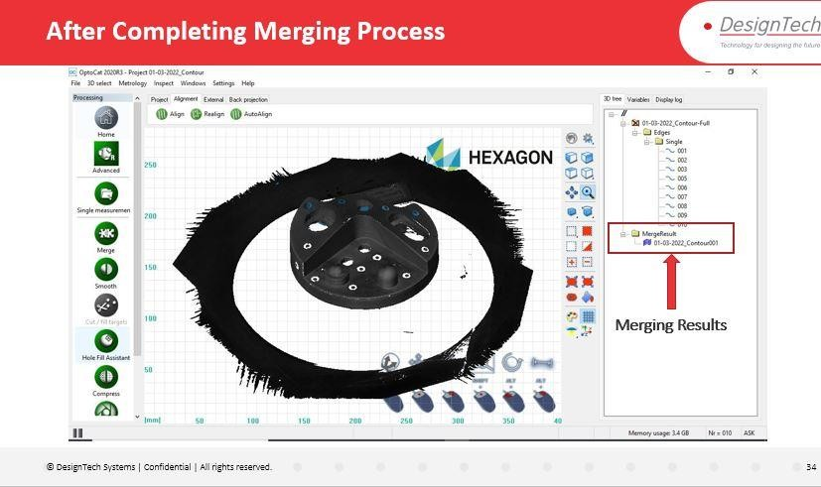



Description:

After Merging of Captured Data, we can find the Merged File Under 3D tree.

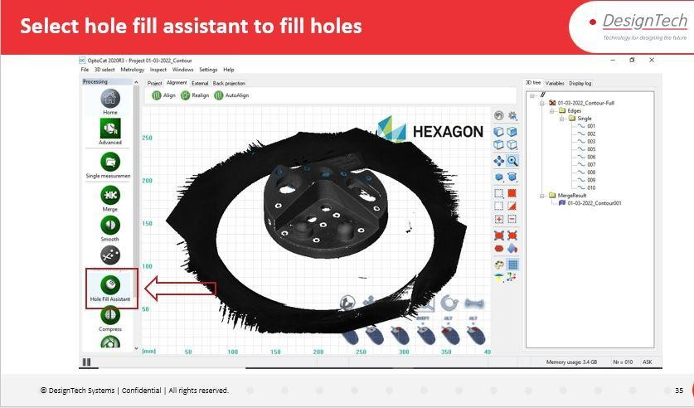

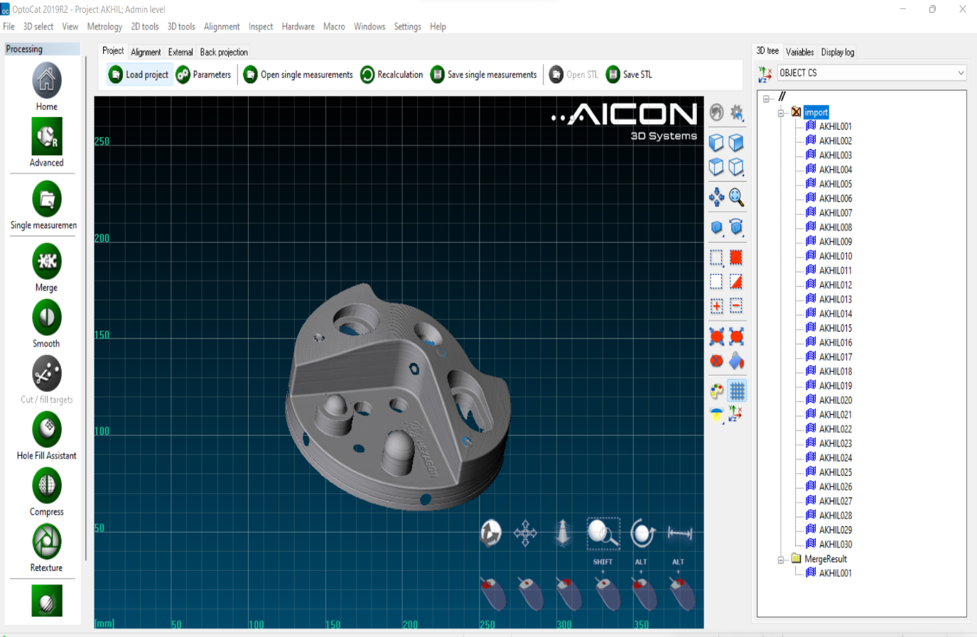

Description:

Click on **Hole Fill Assistance** to fill the Holes.

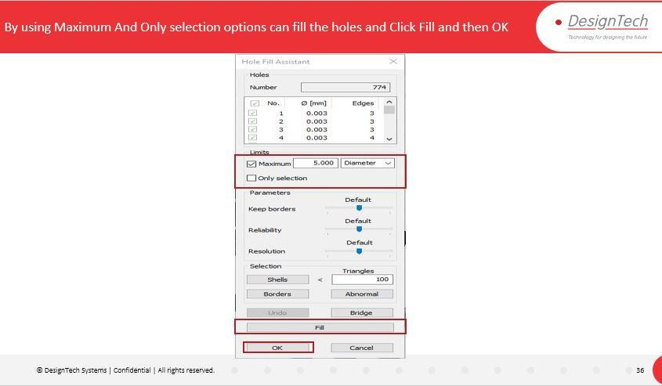

Description:

Select Required Option and click on **Fill** to fill the Holes.

**Maximum**: By Enabling this Option we can fill Maximum diameter holes which we have to specify Diameter Value.

**Only Selection**: By Enabling this option We fill the Selected holes.

Click **OK.** After Completion of Filling Holes.

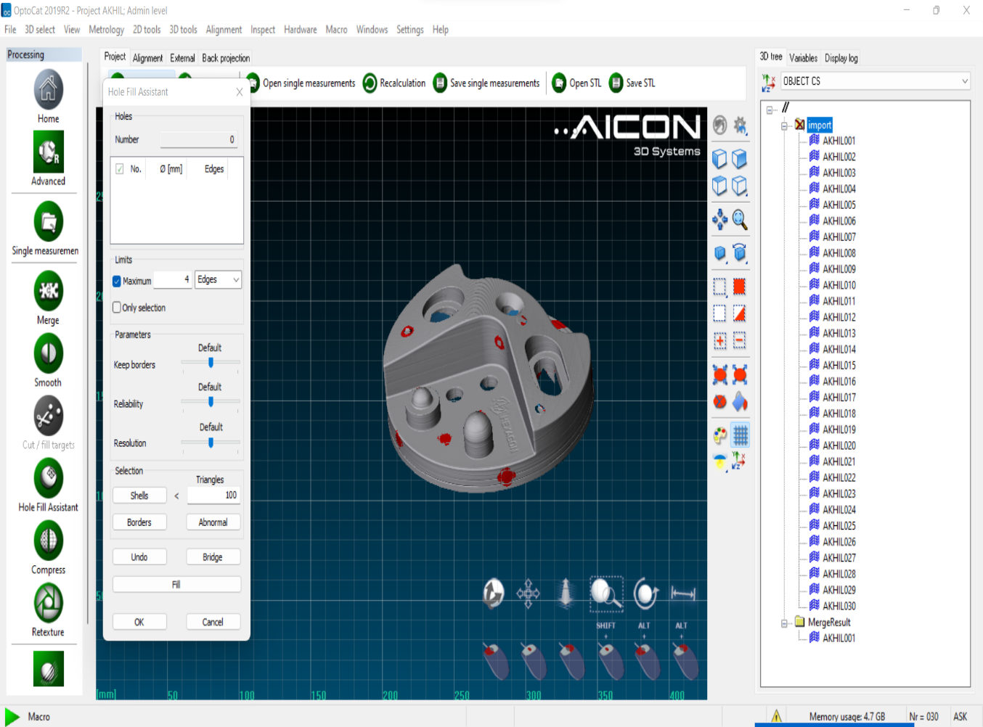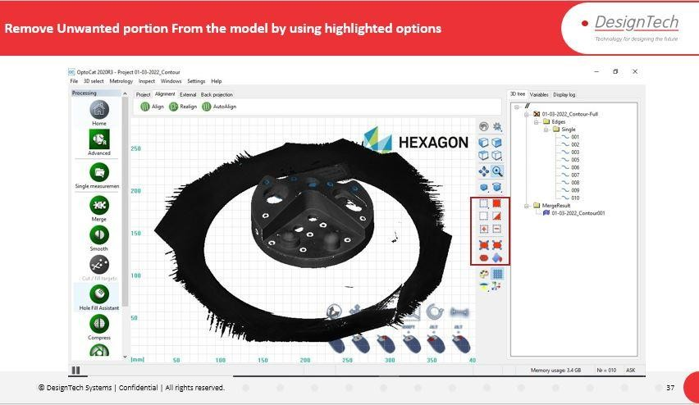

Description:

By using Cleaning and Selection Options We can clean/Remove the Un wanted Portions from the Model.

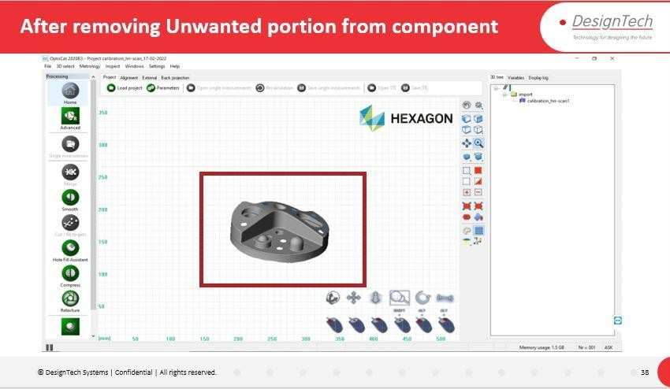



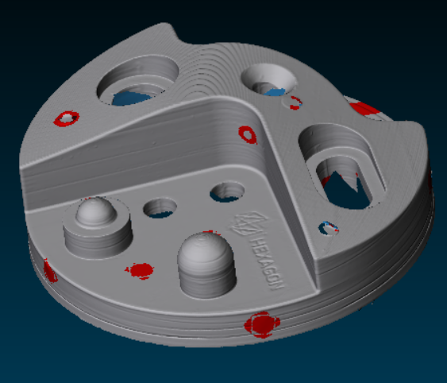

Description:

After Completion of Filling holes and cleaning the Geometry The file will save Automatically in the Saving Location.

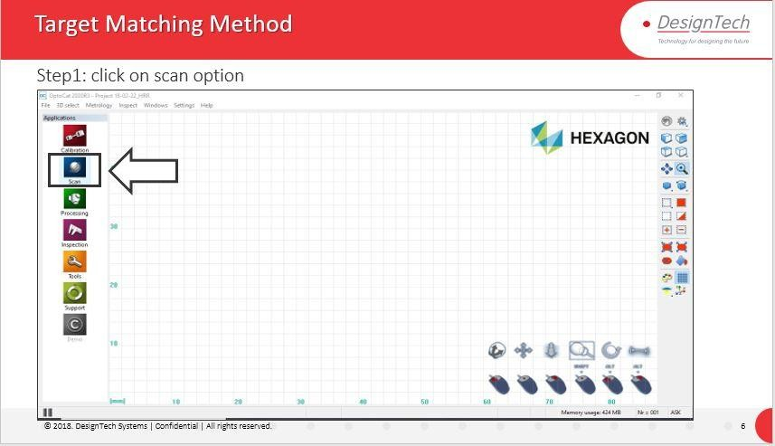

Description:

Click On Scan Option.

Scan Option Will Take us to Window to Capture the Model.

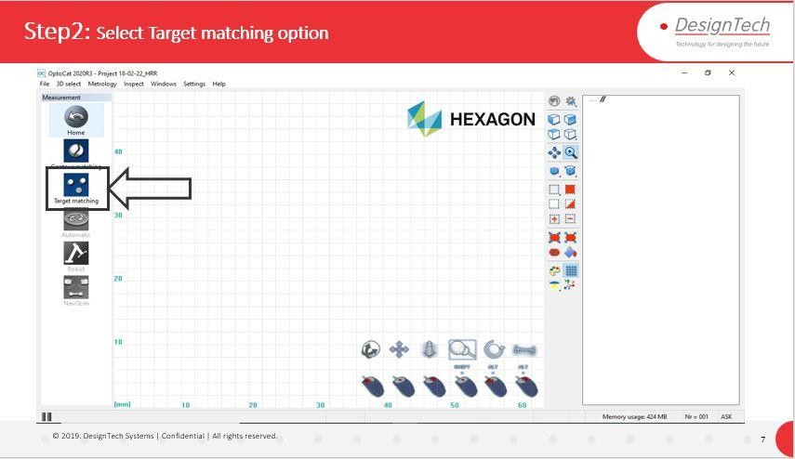

Description:

In Scan Window We Can Select the type of Scanning Method.

Select **Target Matching**.



Description:

Select **New Project** to Create New Project to continue Scanning Process.



Description:

Name the Project and Specify the location and Click OK.



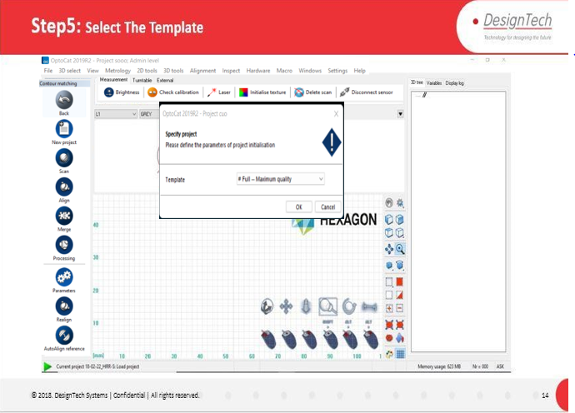

Description:

Select Template which uses to Capture Data from Model/Component.

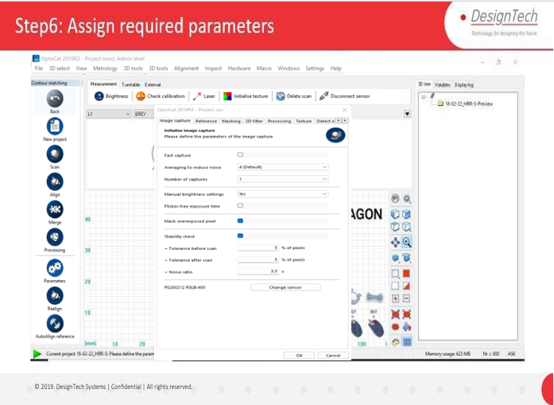

Description:

Specify the Parameters from Parameter window.

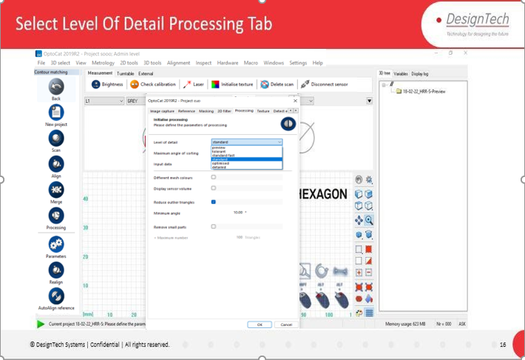

Description:

In the **Processing** Tab Select **Level of Detail** to get the Data Accurately.

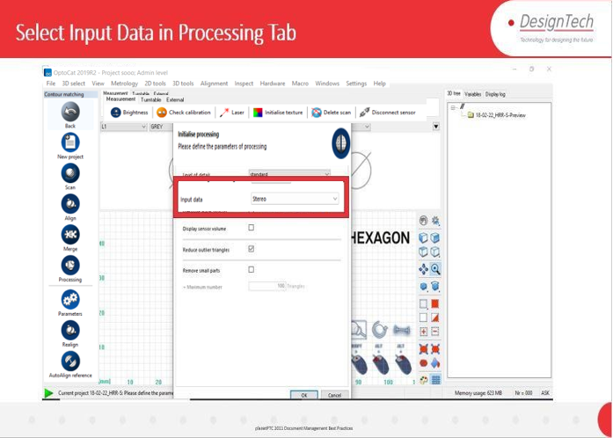

Description:

After Selection of Level of Detail Select **Input Data** from Processing Tab Again.

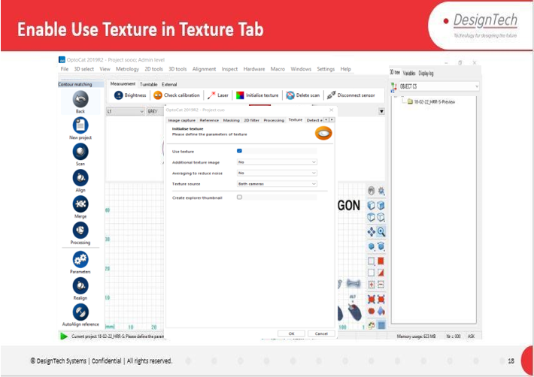



Description:

Click On **Texture** Tab and in Texture Tab Enable **Use Texture** Option If we want to scan the model along with Texture of Component.

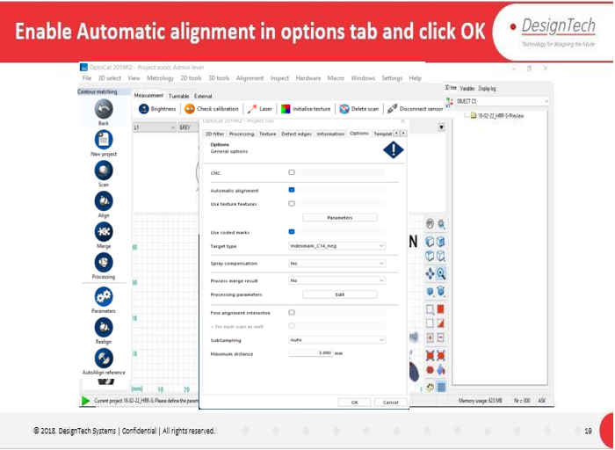

Description:

Now Click on **Options** Tab and Enable **Automatic Alignment** which align the

captured data of component automatically. If we didn’t Enabled, then we have to align the Captured Data Manually by Picking up the Similar Point Location on the captured model.

Click **OK.**

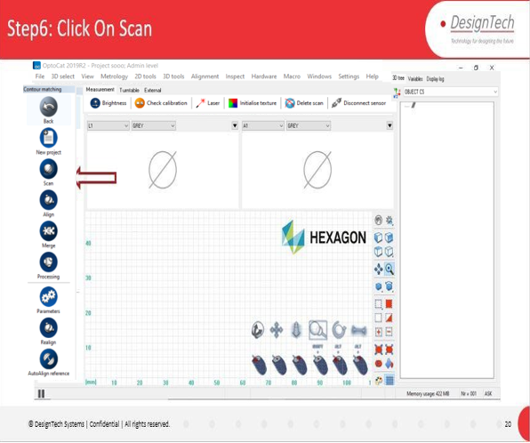

Description:

Click on **Scan** Option to start the Scanning Process.

**Sensor** Dialogue box will Appear.

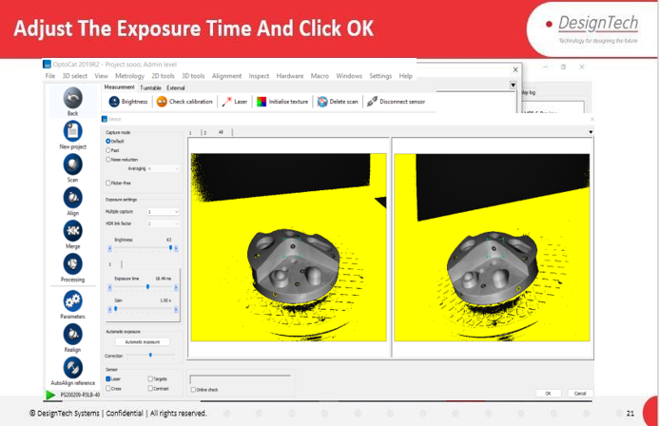



Description:

In **Sensor** Dialogues Box can adjust the **Exposure Time** Bar to Increase or decrease the Light Reflection and Data Capture Accuracy on the model component.

We can change Noise Reduction and Brightness.

We can Use **Automatic Exposure** to Adjust the Light Reflection automatically.

Enable **Laser** Option Under **Sensor** Section.

By Capturing the Target points on the component Software Will Capture the data and Click **OK.**

Scanning Will start and It Will Capture the Component Data.

Repeat the Same Procedure Until we capture the Complete Model Data from all Directions of the component.



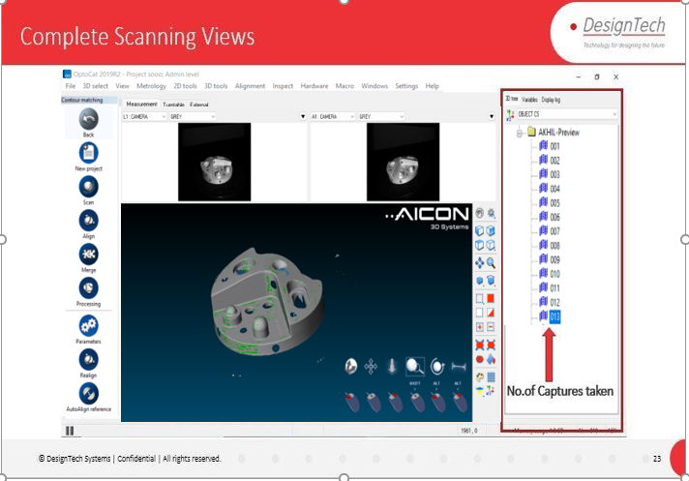

Description:

After completion of Scanning Process, we can find the Captures from 3D tree Tab.

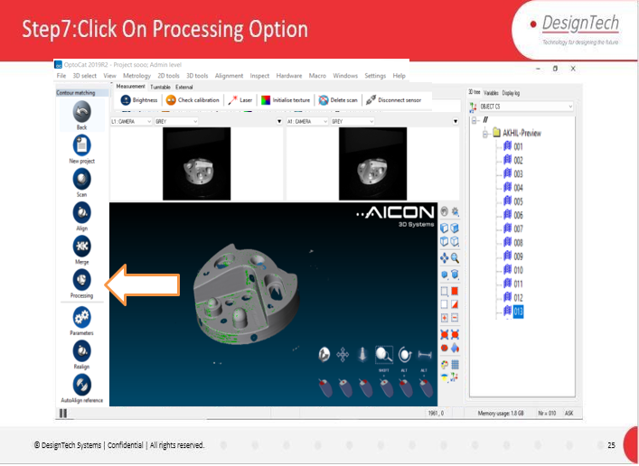

Description:

After the Scanning Process Click on **Processing** Option to proceed for Data Processing.

It will redirect to Processing Window.

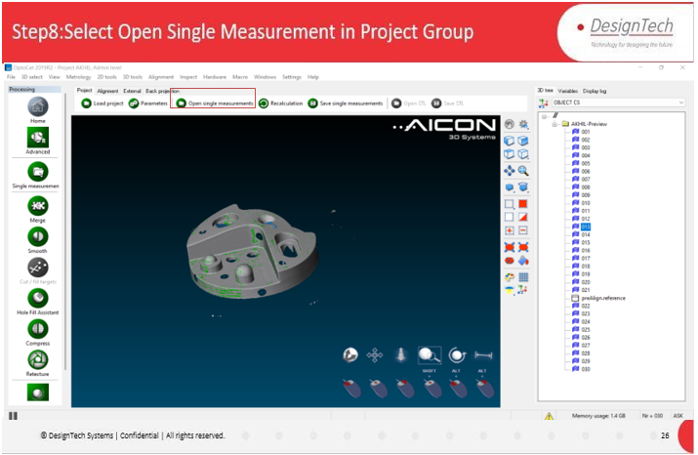

Description:

In Processing Window Click on **Open Single Measurements** option to Open the Multiple Scanned Captures.

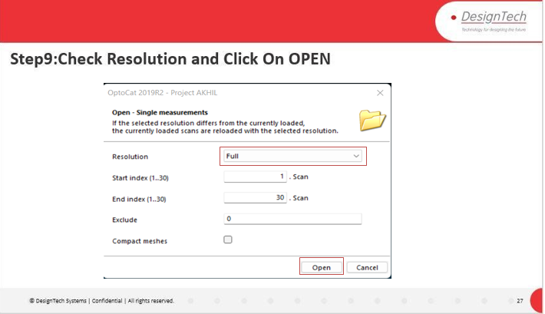

Description:

In Open Single Measurements Dialogue Box Select **Resolution** as **Full** and Click on

# Open.

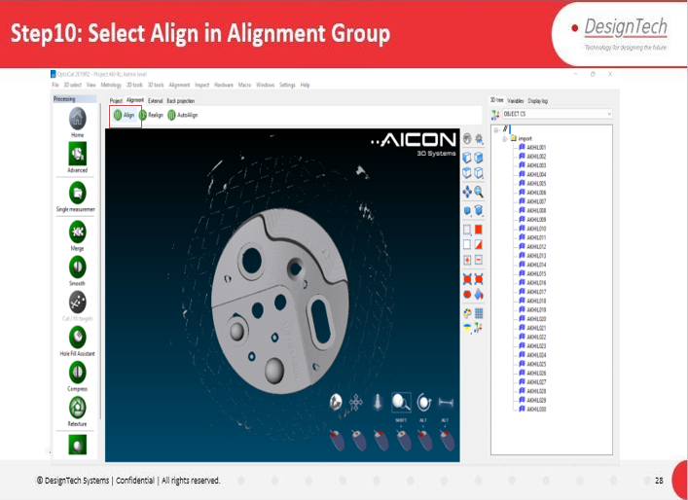

Description:

After Open the single Measurements Click On **Align** Option in **Alignment** Tab. To align the Multiple Captures in to Proper Shape and Position.

Align Dialogue Box Will pop up.



Description:

Click on **Start** Option in Align Dialogue box which will starts the alignment of capture of model.



Description:

Alignment Process will start with 30 iterations which we can find in the dialogue box.

After finishing of Alignment Process with 30 iterations Click on **OK.**

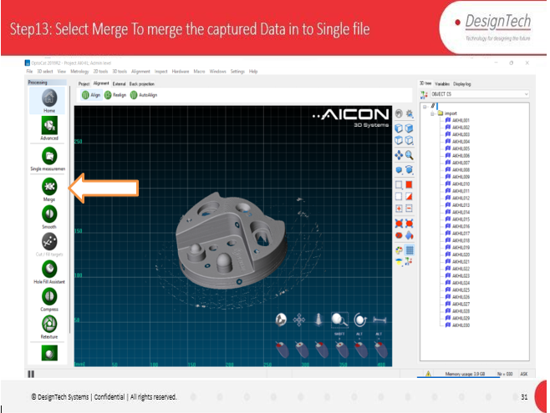

Description:

Click on **Merge** Option after completion of Alignment Process.

Merge option will merge the multiple captured data in to Single Capture Data.



Description:

In Merge Dialogue Box Check the details and Click **OK.**

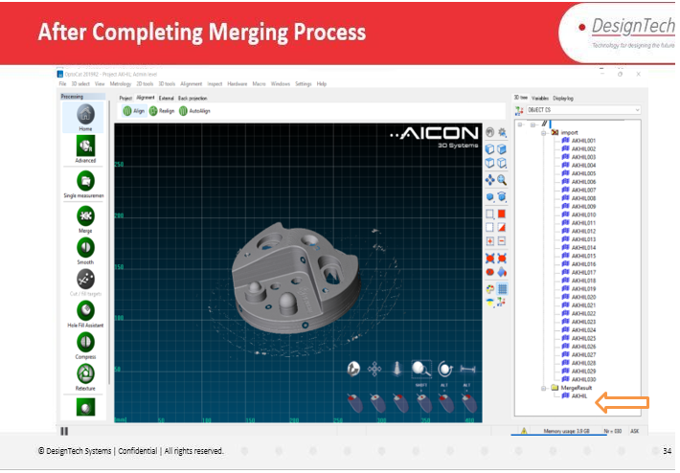

Description:

After Merging of Captured Data, we can find the Merged File Under 3D tree.

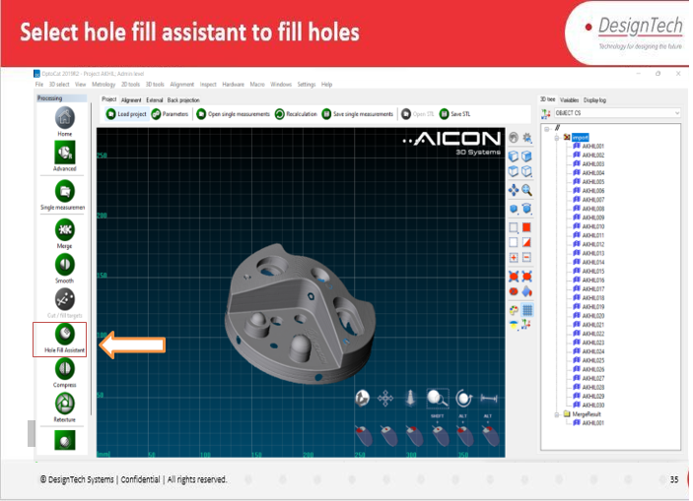

Description:

Click on **Hole Fill Assistance** to fill the Holes.



Description:

Select Required Option and click on **Fill** to fill the Holes.

**Maximum**: By Enabling this Option we can fill Maximum diameter holes which we have to specify Diameter Value.

**Only Selection**: By Enabling this option We fill the Selected holes.

Click **OK.** After Completion of Filling Holes.

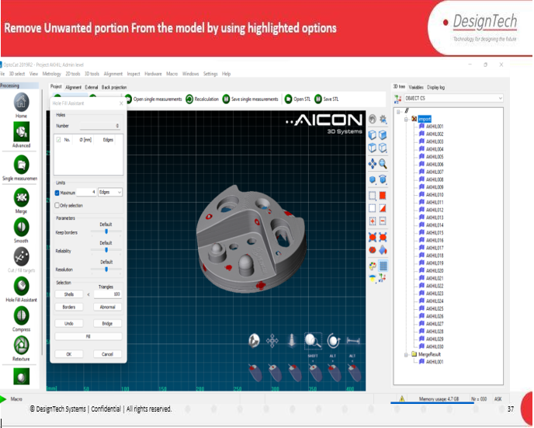

Description:

By using Cleaning and Selection Options We can clean/Remove the Un wanted Portions from the Model.

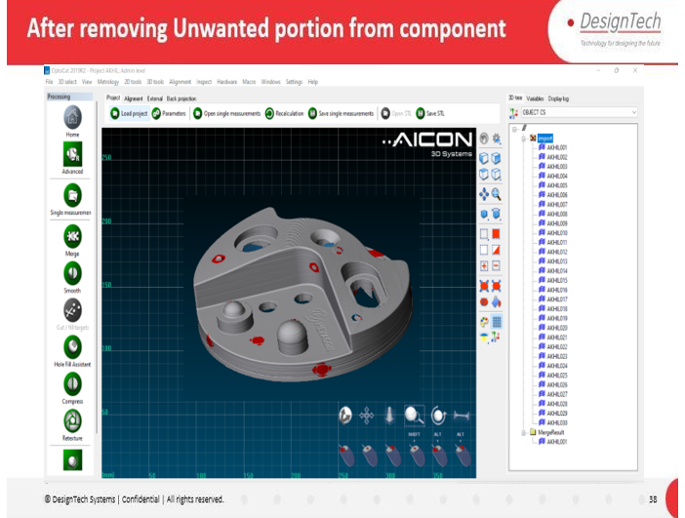

Description:

After Completion of Filling holes and cleaning the Geometry The file will save Automatically in the Saving Location.

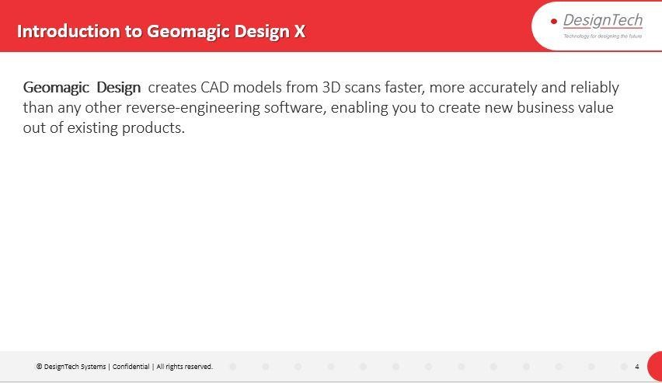

Description:

Introduce about Geomagic Design X.

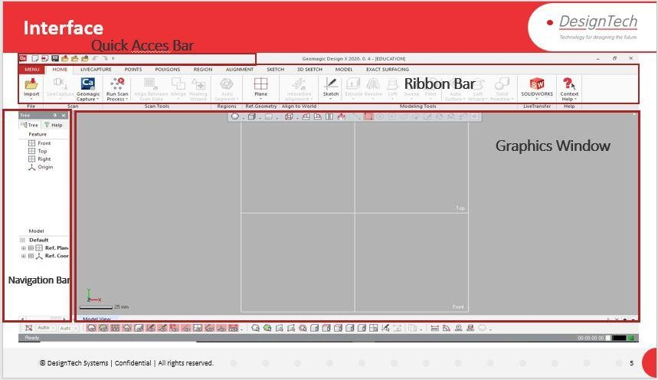

Description:

Explain About Interface of Geomagic Design X.

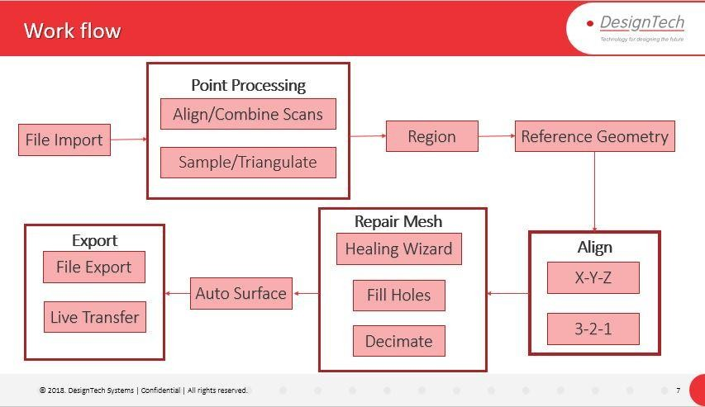

Description:

Explain the Workflow in Geomagic Design X.

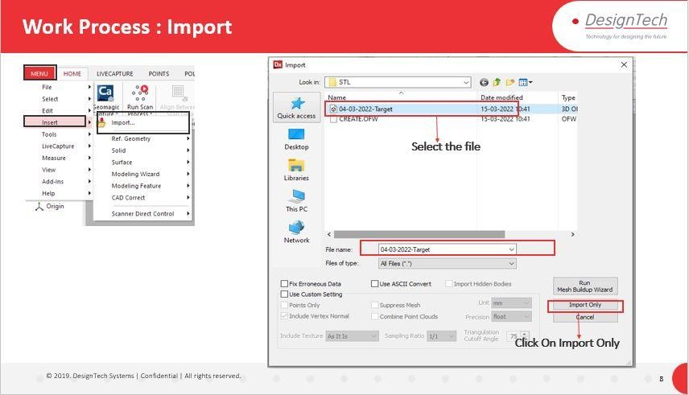

Description:

Step1: Import the File from any scanning Environment.

Menu>Insert>Import>Select the file to import>Click on import only

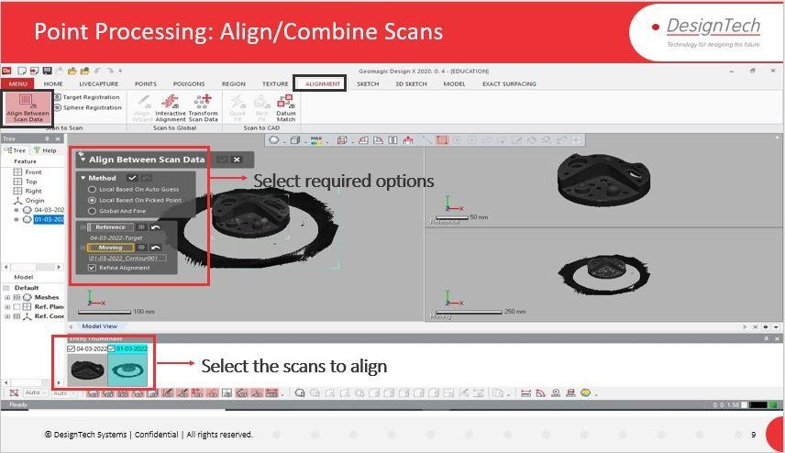

Description:

Step2: After Importing the file Align the scanned data (if not done in Optocat Environment) by using Alignment Between Data in Alignment Tab.

Alignment Between Scan Data Tab We Can Use Different Methods to align Scans.

Alignment>Align between Scan Data>Select Method>Select Reference and Moving>Click on Tick Symbol

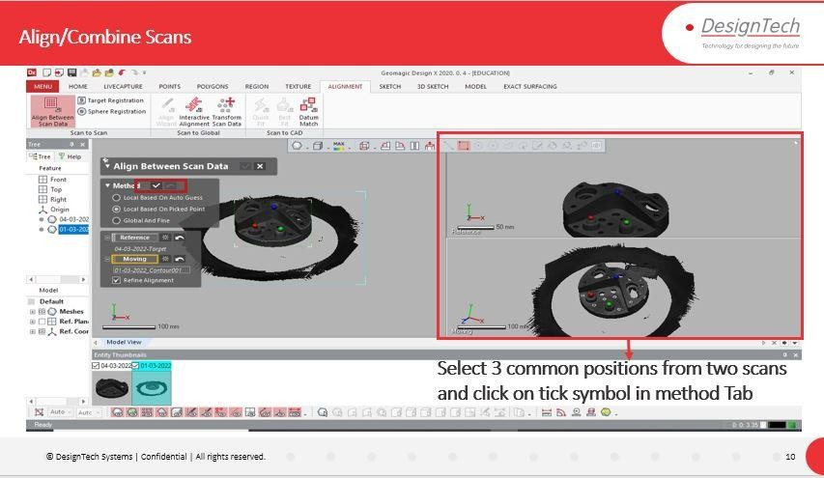

Description:

Select 3 Common Positions on the captured Scanned Data Which Will Align the Captures.

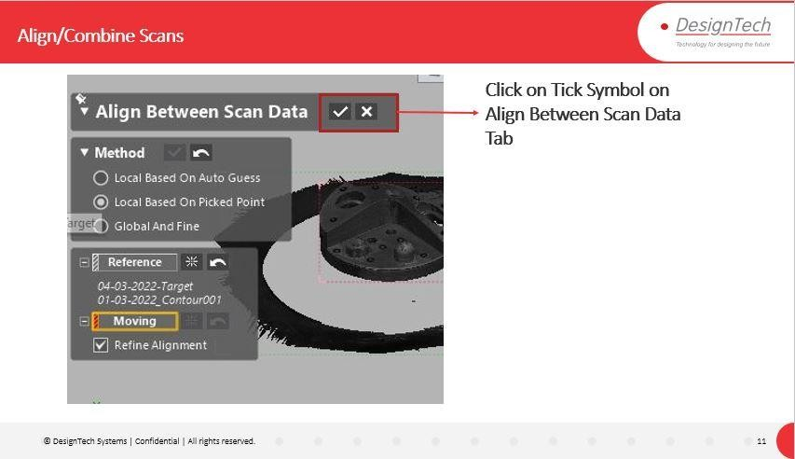

Description:

After Selection of 3 points on the model and Chooses the proper method Click on Tick Symbol on the Dialogue Box to finish the Alignment Process.

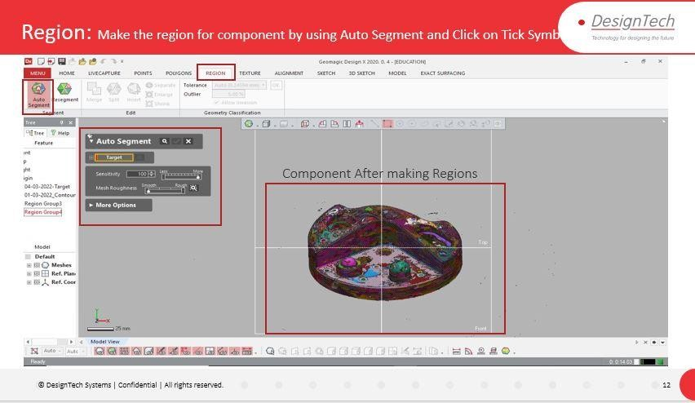

Description:

After Alignment of Scanned Captured Data Create Regions of surfaces on the model component by using **Auto Segment** Option under **Region** Tab by selecting the model component and Click on Tick Symbol to Create Regions.

The Regions Will Create.

Region>Auto Segment>Select Target>Adjust Sensitivity>Click on Tick Symbol.

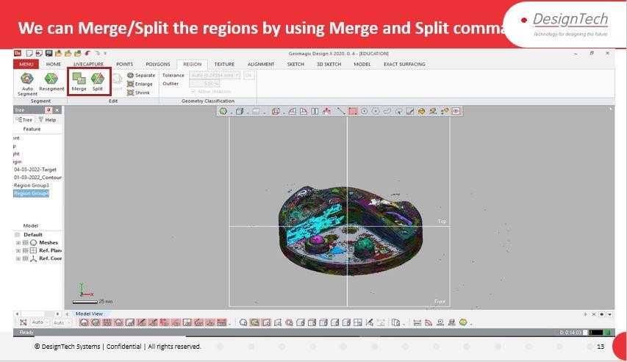

Description:

After Creation of Regions by using **Merge** and **split** Options under **Region** Tab.we can Merge the surfaces and We Can Split the Regions by selecting the created Regions.

Region>Merge/Split>Select Region to Merge/Split>click on Tick Symbol

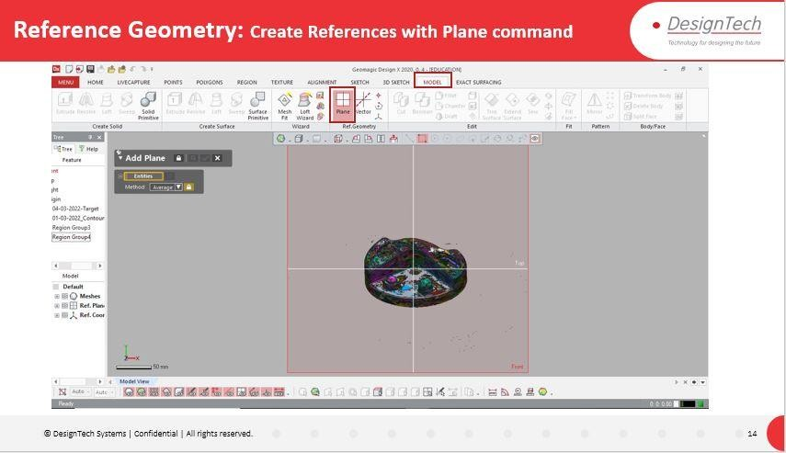

Description:

After Merge or Split of Regions Create References for the geometry by Creating Planes Using **Plane** Option Under Model Tab in **Ref Geometry** Group. So, that we can modify or repair the Geometry.

Model > Plane > Select the face on Component>Select the Method>Click on Tick Symbol

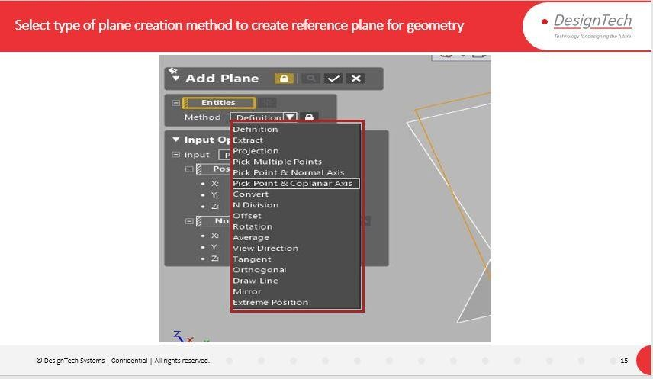

Description:

By using Different methods, we can Create Planes for Reference Geometry.

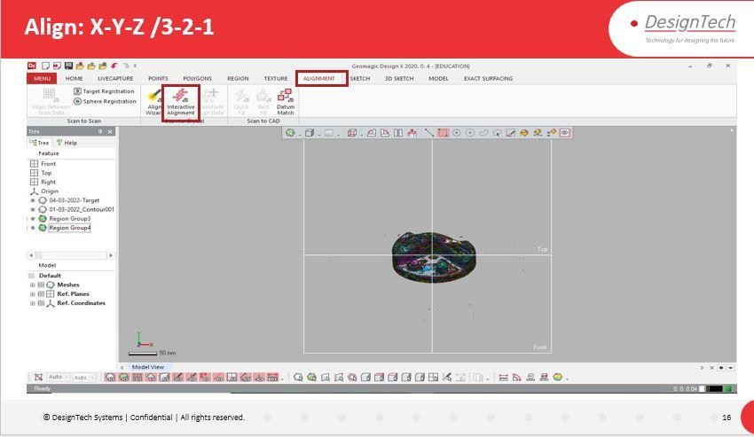

Description:

After Creation of Reference Planes Align the Geometry by using Reference planes by Selecting the Planes with **Interactive Alignment** option under **Alignment** Tab.

Alignment>Interactive Alignment>Select X-Y-Z/3-2-1 method>Select Reference Planes > Click on Tick Symbol.

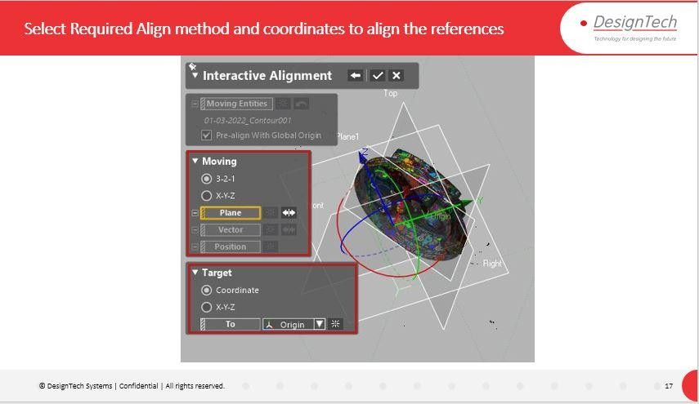

Description:

In Interactive Alignment Dialogue box We Can Align the geometry by using reference planes with **3-2-1** and **X-Y-Z** Methods.

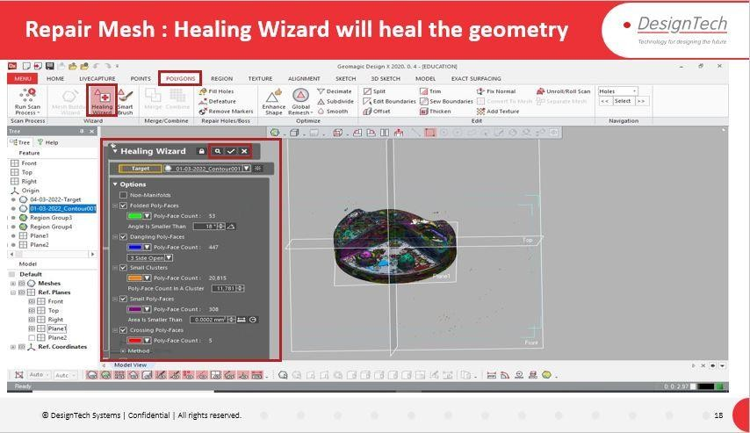

Description:

Click on **Healing Wizard** Option Under **Polygons** Tab in **Wizard** Group to Fix the distortions in the geometry.

Check the Features and Click on Tick Symbol to run the healing Wizard to fix the distortions in the Geometry.

Polygons>Healing Wizard>Select Target Component>Check the features> Click on Tick Symbol.

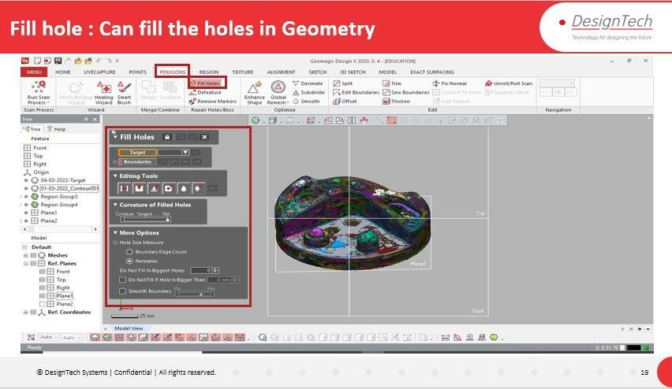

Description:

After Running the Healing Wizard by Using **Fill Holes** option in **Repair Holes/Boss** Group under **Polygons** Tab to Fill the Holes if Required by using different methods available in Fill Holes.

Click on Tick Symbol to complete the Fill Holes Operation.

Polygons> Fill holes> Select Target and reference>select Editing tool method to fill hole>Click on Tick Symbol.

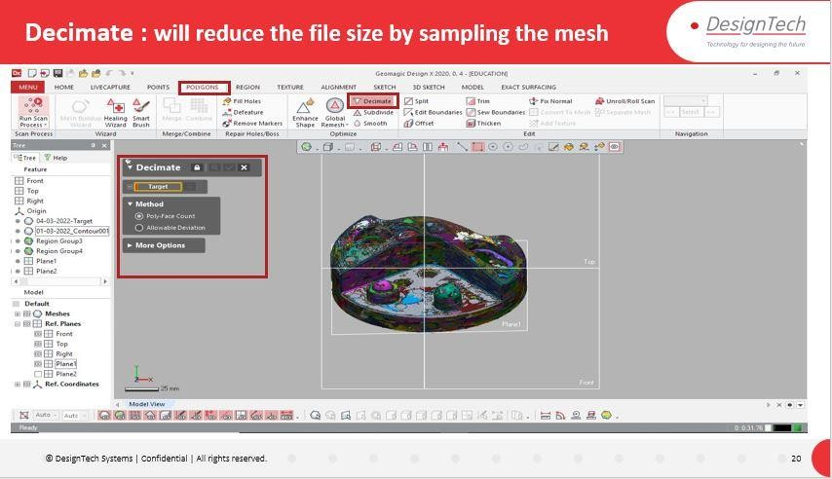

Description:

After Fill Holes Operation by using **Decimate** option in **Optimize** Group under **Polygons** Tab which decreases the file Size by Checking the **poly Face Counts** or by **Allowing the Deviation** Methods.

Click on Tick Symbol once component Selects.

Polygons> Decimate>Select Target> Click on Tick Symbol.

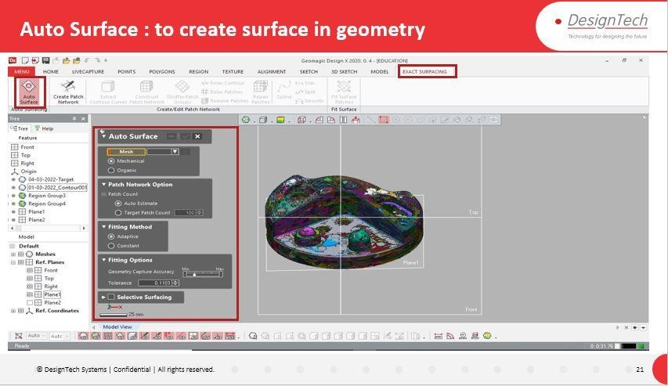

Description:

After Decimate Create surface by using **Auto Surface** Option in **Auto Surfacing**

Group under **Exact Surfacing** Tab.

Click on Tick Symbol after selection of Model Component.

Exact surfacing >Auto Surface>Select mesh>Select Patch Network Option>Select Filling Method> Select Filling Options>Click on Tick Symbol.

With this Geometry Modification is completed and now we can export the same file in to Any CAD tool environment for Drafting purposes and for further modifications required.

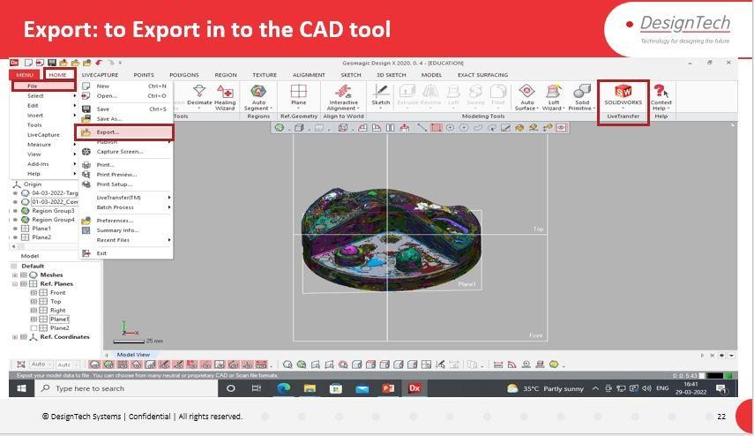

Description:

By using Export Option, we can Export the file to any another CAD tool Environment for further process like Drafting and Design Modification.

Menu>File>Export>Select the component to be export>specify the Saving Location path>Select Format>Click Ok